The DOVE-TAIL-Puzzles of Moshé Zwarts
by Fred Horn

====================================================================

In CFF 89 on page 35 some DOVE-TAIL-Puzzles of prof.ir. Moshé Zwarts are mentioned.


In 2002 I wrote about these Puzzles and my article on the subject was published in the monthly Magazine Natuurwetenschap & Techniek No.72 of Februar 2002, relating to all (till that moment) found solutions.
As “a Question and a Puzzle” I did ask the readers of the Magazine to think about more possible solutions, but up till today no other solution has been found.

====================================================================

The Dove-Tail-Puzzles of Zwarts were part of an Exhibition (“Oratie in Beeld”) of Designs and Objects realised by Zwarts through the years, in “het Gebouw van BOUWKUNDE” of the former THD in Delft from 25 April to 20 May 1983.
Some years later my collegue Thijs Edelkoort from the Rijksgebouwendienst draw my attention to these puzzles he had seen at the Exhibition.
After contacting Moshé in 1986 he did not know where the puzzles were stored, but he found a Catalog and was so kind to give it to me.
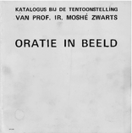

My article was, for a large part, based on what was written in this Catalog.

The Puzzles

The young Moshé once saw that strange object, which at first sight looks unsolvable.

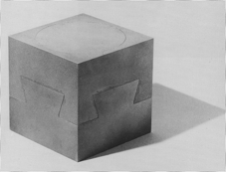

But, of course as anybody knows, after some trial and error most people will find the solution by sliding the 2 parts of the Puzzle diagonally.
But this was not enough for the young Moshé . He was intrigued by the Idea of these Dove-Tails and he asked himself: “Are there more?”.
His basic assumptions were :
1) The outside-look is that of the original Puzzle
2) Inside there are no Holes
3) The Puzzle consists of 2 parts which can be seperated and also put together again.
After he did find quickly a second solution it became nearly an Obsession to find more.
Through the years one after another more variants were found.

But the original Dove-Tail-Puzzle was also used in a construction of more Dove-Tail-Puzzle-pieces as part of the Exhibition:

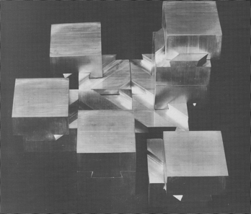

N.B. The original photographs printed in the Catalog are of such bad quality that I will further use the drawings from the Article in “N-W & T”.

This is the original Dove-Tail-Puzzle:

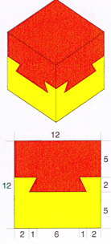

And this is the way you have to slide to solve the problem:

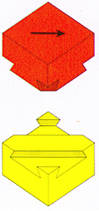

But soon thereafter young Moshé found his second solution, not sliding but turning:

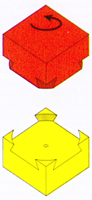

In a way “sliding in a plane” and/or “rotating round a line” seem to be the movements to build Dove-Tail-Puzzles and make it possible to separate the 2 halves.
Growing older and becoming wiser did not tempered Moshé’s passion to find more possible solutions.
Thinking along the same lines which brought him his second solution he realized that rotating around the vertical line through an edge also will do, thus finding number 3:

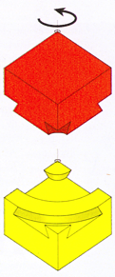

In fact the vertical line around which to rotate can be anywhere placed in the diagonal plane.
This will give in fact an endless amount of solutions, for which number 1 (the original Puzzle) is the special one where the line is in infinity and number 2 the other special one where the line goes through the middle of the Puzzle.
Not all the possibilities, when the line goes through the body of the Puzzle, can be count as solutions because from some point on the 2 parts of the Puzzle still can move but they can not be separated.

But the possibilities with only turning where not yet exhausted.
Turning around a horizontal diagonal also will provide solutions.
Again this nr.4 is a whole serie of solutions:

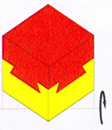

When the line goes straight through the middle of the Puzzle there is no solution because the 2 parts can not move.
When directing the line up or down it will occur that from a certain point on the 2 parts not only move but can also be separated from eachother giving all solutions nr.4.
At the moment there is no calculation done where exact the 2 parts start separating.
Also there is no proof that turning right will be equal to turning left.
Reaching infinity the original Puzzle comes to light again!

But using a different line for rotating, this time going through two opposite edges of only the lower part of the Puzzle gives solution nr.5 :

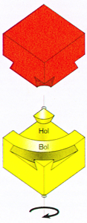
‘Hol’=HOLLOW and ‘Bol’=ROUND.
And then it seems for a long time as if the “puzzle within the Puzzle” was solved, when Moshé’s associate Rein Jansma did find once more a solution, nr.6, by using only one movement: “sliding under a degree of 45∘” :

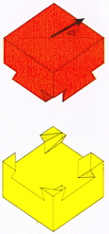

Moshé himself found solution nr.7 using a composite movement, ‘turning and sliding’:

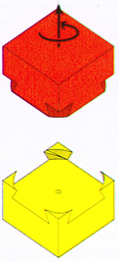

And there the story ends so far!
De BIG question for Zwarts in 1983 was of course: “Do I have ALL solutions?”.
And today that question still stands and we keep in the dark, asking ourselves:
“Is there more?”.

The Hague 12/28/2012

