LONG TAU The Chinese DRAGON-game
© M.J.G.Thomassen Illustrator 29 May 1943
====================================================================Introduction by Fred Horn:
In the late Seventies of the last Century I was asked to make an inventory of all games stored in the Attick of the Jumbo-headquarters in Amsterdam.
One of my finds there was this game which mr. Thomassen had send to Jumbo in 1943 to get an ordeal about the possibilities of publishing it.
That never did materialize and Jumbo also did not returned the Prototype.
When I tried to find more about the Game and its Author, privacy-rules made it (for me) impossible to get access to the Files: you have to be Family or you must have a declaration of a University that you are doing scientific research.
The prototype is now in the Amsterdamsch Historisch Museum.
The Speelgoed-Museum in Deventer also owns a version of the game, which could indicate that (probably in small numbers) the game has been published elsewhere.

The Game-Rules I present here in English are an exact translation of the original
typed rules from mr.Thomassen.
He then (1943) lived in Amsterdam; Leonardostraat 3 (1 hoog); tel: 22234
===================================================================
LONG TAU, the Chinese dragongame

LONG TAU is an old Chinese game, in which the dragon who has to be sitting in the middle of the game-board on his golden chair, presses his mark.
Within Chinese thoughts a dragon cannot be killed, only tied, so the aim of the game is not to “capture” opponents’ pawns, but to “besiege” these pawns and make them harmless.

Around the Golden Chair are 4 play-areas, connected by straight lines, each with 22 squares. When LONG TAU is played with TWO , only 2 opposite areas are used and both players place 22 pawns on the squares.
(N.B. handwritten is added: ‘color!’ so each player has his own color. F.H.)
Players draw lots who starts.
The pawns can only move along the straight black lines, as far as possible, which means:
till the end of the line or when meeting an own pawn or an opponents pawn. This strange way of movement of the pawns is one of the ‘enchanting things’ of LONG TAU.
Jumping over pawns during a move is not allowed.
Players turns are alternately.
When a player succeeds in completely surrounding an opponents pawn, he removes this pawn in his next turn and also moves one of his own pawns.
A pawn is besieged when he is completely surrounded by enemy-pawns and cannot move. Sometimes a player needs 3, sometimes 4 pawns for this enclosure. This depends on its place on the board. If a pawn is surrounded by 3 opponents pawns and one own, and this own pawn can still move, then de besiege is not complete and the pawn cannot removed.
It is also possible to besiege a whole group of pawns. The one condition is that the surrounding is really complete. In that case the complete group may be removed from the board.
If a player can occupy during his turn the 4 squares of the Golden Chair then he can remove in his next turn the 4 opponent pawns which are situated the farthest from the Golden Chair.
If a player want to do this agsin he first has to move one of his pawns from the squares around the Golden Chair, to return in his next move. This gives the opponent the opportunity to occupy this empty square and thus save his game.

The first player without pawns on the board, looses the game.
Is LONG TAU played with FOUR, then each player starts in his area with 12 pawns, situated on the 12 squares the nearest to the players edge of the board. The 2 opposite players play against the other 2.
(N.B. it is clear that the “partners” play with the same color. F.H.)

Necessaries: 48 pawns, in 2 sets of 24 pieces, in 2 colors.

====================================================================
On 29 May 1943 –the date I did use for the copyright date- mr. Thomassen send a Letter to Hausemann & Hötte in which he gives a further explication of the rules.
====================================================================

Dear Sirs,
As a result of our conversation on the telephone, I summarize below in short the rules!
The game may be played by 2 or 4 persons, respectivily with 22 or 12 pawns ( the line-up with 12 pawns is upon the squares at the back part of the board).
The game is based on the principle of removing pawns of the opposite party by:
1) enclosure /besiege
2) ‘making’ the Golden Chair (the inner Square)
A pawn is besieged when it is completely surrounded by enemy pawns and is unable to move.
Also more pawns (grouped together F.H.) may be besieged as a whole,
When the Golden Chair has been ‘made’, 4 opponents pawns may be removed from the outside squares.
The movement of the pawns is along a straight line. A pawn must move up to the end of the line where this line changes direction, or up to the point where another pawn ‘blocks’ further movement.

If you require further verbal explication, I will be with pleasure at your diposal.
I do hope to hear from you in the near future, yours faithfully,
M.J.G.Thomassen

====================================================================
N.B. Unluckely for mr. Thomassen Jumbo never answered!
LONG TAU Board:
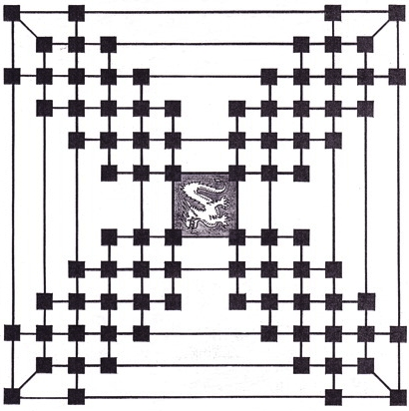

====================================================================
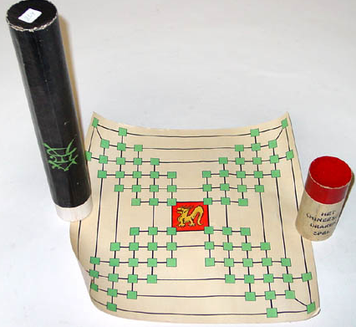
This is the LONG TAU Dragongame

from the collection of the

SPEELGOED MUSEUM Deventer.

