Subject for a Presentation on BGS 2016
at Spiele-Archiv Neurenburg 13-16 april 2016
===============================================================

Schada Het Wereld Spel ( The World Game ) by Fred Horn

- On the 24th of June 1974 the daily-paper “De Tijd” published an article about native-Rotterdammer Jan Boogerd, the inventor of –as he himself stated- De grootste denkmeter ter wereld (the ultimate thinkmeasurer in the world
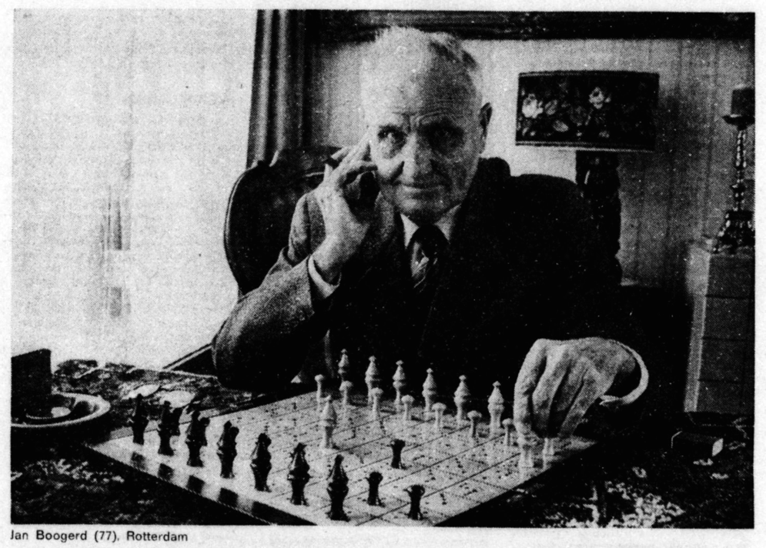
Boogerd is than 77 years of age and he also gives his address:
Kerstroosstraat 6 Rotterdam.
This for the interested Publishers, he says, so they can find him easely for his latest invention “Vliegende Vogel” (Flying Bird), a dexterity-game for children.
He also mentions: “ I am now seventyseven and that is why I like the fact that a Game-manufacturer has bought Schada. I presume it will be in the Shops this autumn.”
- When I did start my research in the early 80ties, concerning a)the History and b)the Inventor of Schada, I had no knowledge of this article. Even the first step: searching through the Telephone-book of Rotterdam, did not give me any clue where to find
J. Boogerd.
More research into his personal life was blocked by the Dutch Privacy-Laws, which give only relatives the possibility to explore official Files and Archives.
Thus only a limited story about the game Schada was possible at that moment.
- New research in 2015 uncovered more information about the person J.Boogerd, because his name and data were put into the on-line genealogy-registration.
Jan Boogerd was born on 10 April 1897 in Goes, a small town in the provence ZEELAND, and died in Rotterdam on 2 November 1985.
He was married with Pieternella van der Doe and the couple got 2 sons, both still alive.
In 1940 their address was: Rochussenstraat 179a in Rotterdam-West. The family later moved to the Kerstroosstraat.
- And, after finding one more article from Tuesday 19 Februar 1974 in the Paper “Nieuwsblad van het Noorden”, suddenly there was more background-information available than at the time of my first attempt in the 1980th.
At that time the only information to start with was the Octrooi of the game, an Octrooi that is also referred to by Boogerd in the article in “De Tijd”, with the number 77428.
In those days the Dutch-Octrooi-office (Octrooi-Bureau) was easely to get in touch with and also open for the public each day, so after spending a whole day there I had copied all the available data on Games out of their files, including the information on SCHADA.
The mentioned number by Boogerd concerns the application-number of a request by Theodoor Nicol Maria Jansen from Schiedam dated 16 April 1936, which was made public on 15 September 1937, for the Octrooi No.42613 on a Gameboard.
Dated 15 Februar 1938 the exact identical Octrooi is now published with the name “FIRMA GROENTEMAN & Co. te Amsterdam” which firm did register it (the same text and drawings) on 30 April 1938 as “Invoeroctrooi” in Belgium under No. 426980.
The added drawing of a Gameboard to the Octrooi ( with on any field some ‘marks’ =”merkteekens”=, which give the number of fields and the direction of moving a playing-piece) is more focused on the design of the Board than on the actual rules for a game.
- But how did the game SCHADA developed out of this Board-idea?
A fair guess is that mister Jansen had an Idea for a board but not for a game to play on that board. Probably “inventor” Boogerd has been asked to mould the board-idea into a playable game. Not so unthinkable because Boogerd himself says: “ The Octrooi has expired now. But be aware that it (the game) can not be copied. The ‘authors-rights’ are mine. It is not free for every-one to imitate. Before the war an “Israëliet” {here Boogerd refers to someone with a Jiddish background} sold it for me. That was good selling. “
N.B. It is obvious that Boogerd is wrongly mixing Patent-/Octrooi-rights with the Dutch Authors-rights. His authors-rights are valid then because he is still alive.
Thus Boogerd developed in 1936/37, based on the game-board-idea of T.N.M.Jansen, a game that he first called Janbo (after his own name!), but soon thereafter choose for the name SCHADA (from SCHA-ak- en DA-m-).
In between a version is known with the name “Schaakdam” which was published in 1936 by “Schilte & Zonen Ysselstein”. In the Photoarchive of printfirm “Spaarnestad” Haarlem some pictures of this version survived.
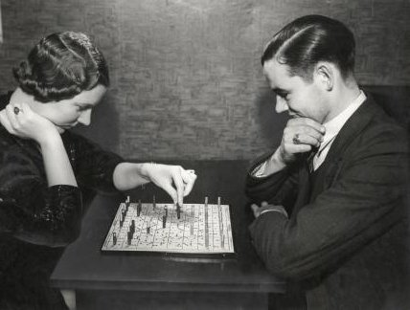
- Jansen’s request was also from 1936, so the application for the Octrooi and the development of the game must have been started before 1936.
The cooperation between Boogerd and the firm GROENTEMAN probably resulted in a ‘take-over’ of the Octrooi by GROENTEMAN. The information is not clear about when this all happened. Did GROENTEMAN, the owner mr.Groenteman was also chairman of “den Amsterdamschen Dambond” (the Amsterdam Checkers Society), ask Boogerd to invent a game after buying the Octrooi, or did Boogerd contact GROENTEMAN after a first try with “Schilte & Zonen”?
We do not know.
The published game by “Schilte & Zonen” only gives ‘Alle rechten voorbehouden’ (All rights reserved), but no indication about an author or Octrooi-application.
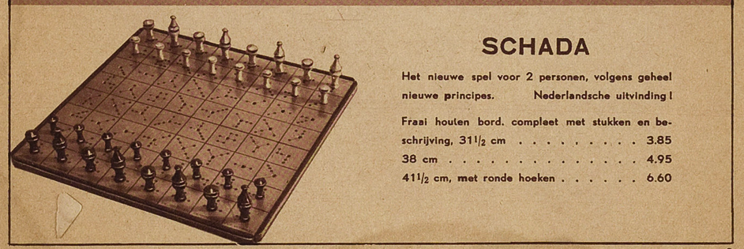
- Already in 1938 the Dutch press reports about SCHADA-tournaments and in the paper “Het Vaderland” of 13 December 1937 a report is written about a DEMONSTRATIE “SCHADA” (Demonstration SCHADA) at ‘het Zuid’ and mr. Groenteman was there in person. In his HANDLEIDING (Rules) from 1939 Boogerd himself refers to played parties during the ‘Persoonlijk Kampioenschap’ (Individual Championship) of Rotterdam in 1938 and 1939.
The leaflet of the firm Perry & Co. from 1938 gives the next offer:
With a good promotion-campaign, started by Groenteman, and a lot of attention from chess- and dam-players as well as from the press the future for the game looked pretty good, but the World-game SCHADA –and also the firm GROENTEMAN- did not survive World War II.
Published before the war is Boogerd’s HANDLEIDING and in the collection of the Koninklijke Bibliotheek in The Hague an other publication can be found as well:

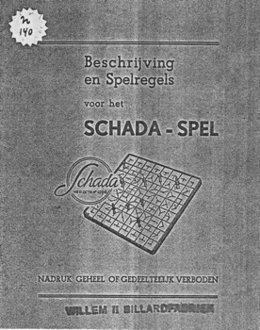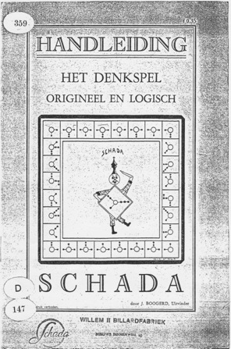

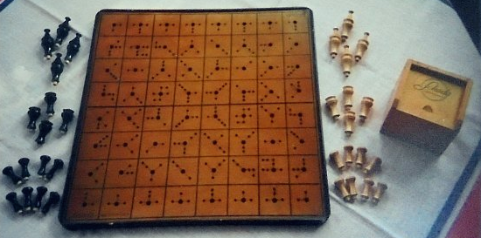
The product-realisation from before the war was a design of a wooden board with rounded or sharp corners. The playing-pieces may be executed in metal, see the photo in “DE Tijd” with Jan Boogerd, or in wood. In this last version the pieces were mostly stored in a small box with the name of the game on the lid:

During the war a simplified cardboard version was published by Multicolor out of Deventer (with K-number ‘K744’):

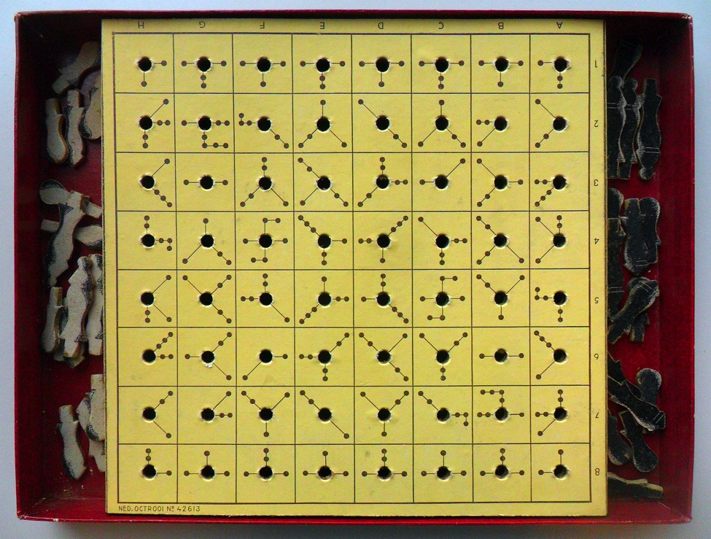

Here is good visible how the ‘marks for moving’ are distributed over the fields!
Two more different designs for board and pieces are known, but information about the data of production or about the publisher(s) does not exists.

++++++++++++++++++++++++++++++++++++++++++++++++++++++++++++++++++++
From Jan Boogerd more ‘inventions’ are known.
He himself gives in the articles in the papers:
= Dambo ‘Dambord Boogerd’ played on a board with hexagonal fields.
= Strada a small pocket-game starting with 105 different possibilities.
= Roldice the rolling dice.
= Vliegende Vogel
and mentioned on the leaflet for the game-rules of the “JANBO PUZZLE” from 1941:
= SCHADA world’s utmost thinkmeasurer for 2 persons.
= DAMSPEL 56 probably the same game as ‘Dambo’ ?
= SPARO - LEG- EN VERDUISTERINGSPUZZLE with a design by J. Boogerd, inventor.
From these out of 1941 only the DAMSPEL 56 is not part of my Collection now at the Vlaams Spellen Archief in Brugge. No trace of this game, outside the image on the pictures in the papers, has been found.
++++++++++++++++++++++++++++++++++++++++++++++++++++++++++++++++++++

But there is still the game Boogerd refers to in 1974. No doubt this concerns the game CORNER, looking at the statement in the folder of Homas recommanding the game as:
“A rare exciting mindgame for 2 persons. Can be compared with checkers or chess.”
That looks quite familiair!
Besides in the “Nieuwsblad van het Noorden” Boogerd himself says that he has reworked his game into a Soccer-game, with pieces valued by their place on the board.
Also the ‘marks’ on the board are quite similar:

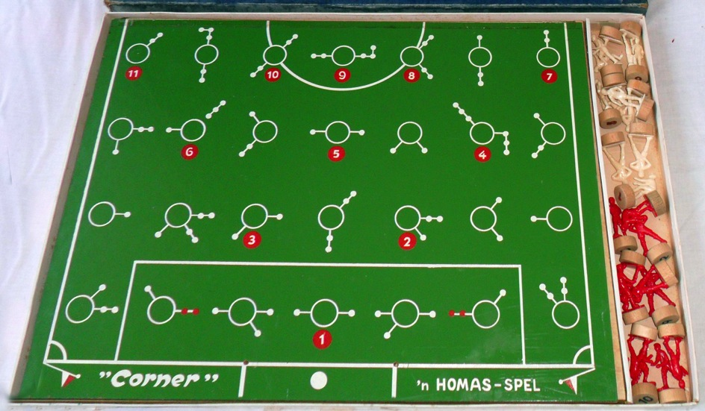

At last some explication about the game- and playing-principle of SCHADA.
The game has nothing to do with either Checkers nor Chess. In fact it is a Halma-variant with the possibility to capture opponents pieces.
Goal is to bring your higher pieces to the opposite side of the board and the real feature is of course the unusual way to move your pieces.
Although not the “World Game” that Jan Boogerd had imagined, it is still for 2 players an interesting strategic game to play.

More information about the game (in Dutch):
http://www.hongs.nl/index.asp?z=schada&zio=j&vi=li

Den Haag, 30 November 2015
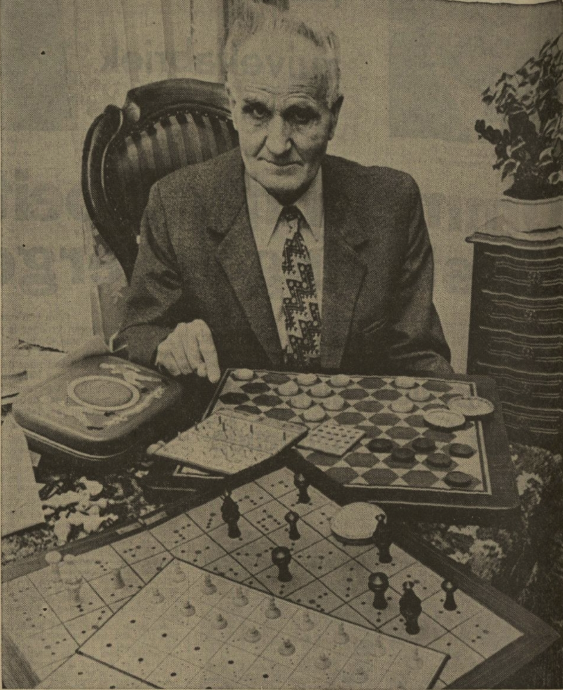

Nieuwsblad van het Noorden 19 februari 1974
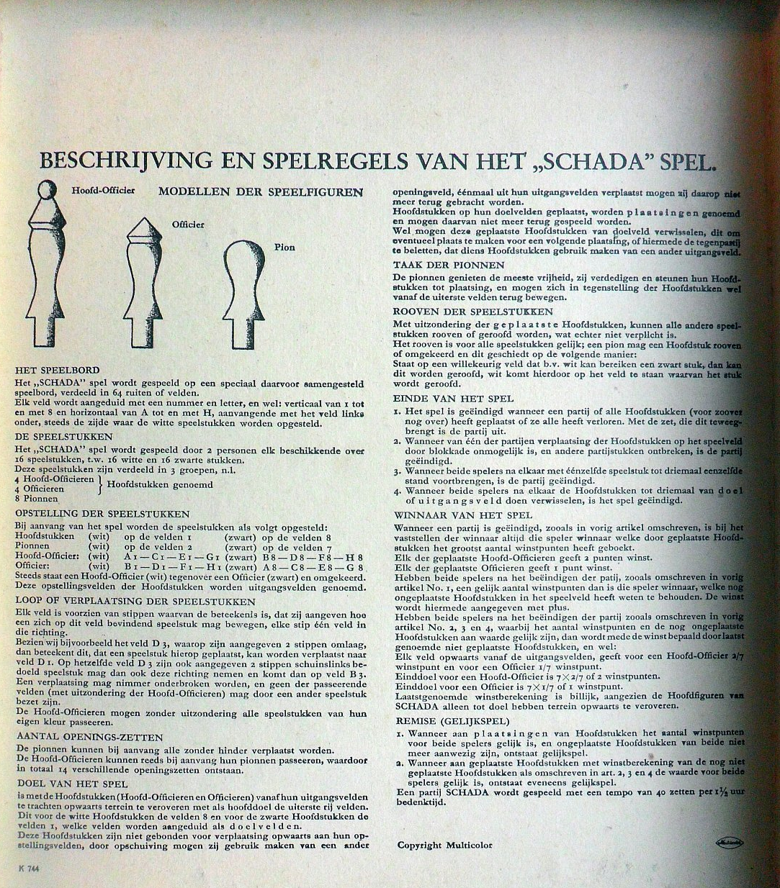
Gamerules from the Multicolor-version (in Dutch):

Nieuwe Leidsche Courant 17 april 1974
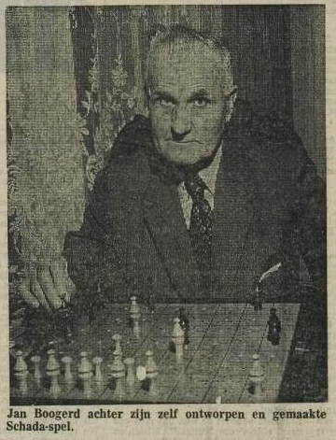
(Jan Boogerd behind his own invented and manufactured Schada-game)
N.B. Both statements are not, or at most partly, true.
The original Octrooi was NOT Boogerd’s.
The game on the picture is the, in 1938 marketed, game by GROENTEMAN and a.o.
sold in the shops of Perry& Co..

