==PUZZLE – 95==
© Fred Horn 1995
====================================================================

INTRODUCTION
This PUZZLE was especially developed for the Convention of Puzzlers, from all over the World, that took place, in 1995, in The Hague in Holland.
To give the Attendance a Challenge I worked out an Idea that already was in my Files for a long time: an Abstract Puzzle within another Puzzle.
In 1995 nobody solved the PUZZLE, and when I started writing Articles on Games & Puzzles in the Dutch Magazine “Natuurwetenschap & Techniek”, the Puzzle was used as “Grote ZOMERPUZZEL” (Big Puzzle for the Summer) in the july/august-2003 issue as (again) a Challenge, but now for the Readers of the Magazine.
There was only ONE proper Solutution by ir. J.A.M.Mes from Budel-Dorplein, that was published in october of that year.
====================================================================

First “Puzzle”:-----------How to make the Pieces and how many Pieces can be made?

The Pieces are all Squares. Each side of the Square is divided into 3 equal parts, giving 2 points on each side:
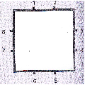

From point to point connections can be made, but a point may be left without a connection. For instance the Square, with no connections at all, also counts as a solution.
The connections are inside the Square and are not allowed to cross eachother or originate in one point:
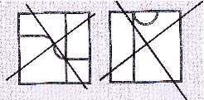

Rotation gives no ‘new’ solution:
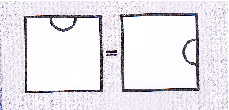

Some examples of Solutions:
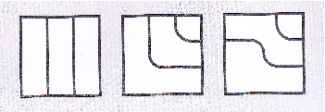

In TOTAL, there are 91 Solutions and this gives thus 91 PUZZLE-Pieces.
====================================================================

Second “Puzzle”------------------How to fit all the Pieces correctly within a Rectangle?

Wat is ‘correctly’?
No ‘lines’ can stay not-continious when a Piece is placed next to another one:
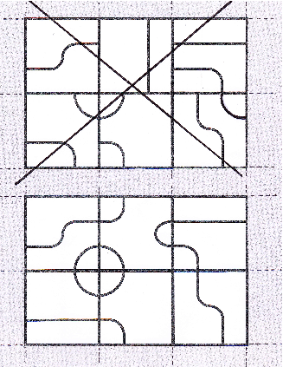

A

B

In A most lines do not continue from Piece to Piece.
In B lines from the six Pieces contine from Piece to Piece.
Note that these pictures represent an inside part of the Puzzle because of the ‘open’ endings at the ‘edges’.
What Rectangle?
With 91 Pieces it is only possible to make two Rectangles: 1 x 91 and 7 x 13 .
The first one is no option because it is obvious that a lot of Pieces do not have a side without a line to be continued.
The Solution must be: a Rectangle with sides of 7 x 13 Squares.
Page 4 gives one Solution for the Puzzle, but there are more!
That again is a Puzzle in itself: “Find all the different ways to ‘fill-in’ the Rectangle with the 91 Pieces”.

More
And there is still more to explore with this Puzzle:
1)
Are there Solutions with ONE continious line and only loose cirkles, other than in the Solution on page 4? There 2 smaller figures exist outside the cirkles and the large figure.
Or: How many ‘closed-line-Figures’ can be made?
2)
By excluding the “All-White-Piece” (the one with no lines) there are 90 Pieces left.
That makes Rectangles of 9 x 10 ; 5 x 18 ; 6 x15 ; 3 x 30 ; 2 x 45 ; 1 x 90 possible.
Can these first two (the others are no options –too less white sides-) be ‘filled-in’?

Den Haag, 12 march 2013 Fred Horn
