Origin of "het SLABBERJAN-SPEL"

"Sta voor de vogel
geen spel
kent dit bevel
dan slabberjan
dit Walchers bovenspelig bezig zijn
is meer dan een herinnering
geen étalage-woord van het verleden
kap aÍ! Roept de ruiter te paard
één hand en één oog
is niet mismaakt
als je voor de vogel staat
de herberg gaan we voorbij
en het poesje krabbelt alles terug
voor mij"

Pier van Damme, poet from the island of Walcheren, tells in this poem about the kind of commands used in the game of "Slabberjan”. His thoughts about “Slabberjan" being the only game where such commands are used is a misunderstanding.
Mr. K. KARELS already assumed, some hundred years ago, an Italian origin but his dating of the game was some centuries short. The Nordic “GNAV” and “Slebber Jen"; the German “VOGELSPIEL” and the Italian “CAMBIO” are related games with striking similarities in rules and requisites.

About the introduction of the game in Walcheren two stories exist:
-1- former Domburg-keeper of the records- H.M.KESTELOO (1842-1918) states his father told him about a certain sailor Serlé, who had brought the game from the West- Indies to Walcheren at the end of the eighteenth century.
-2- Jan Slabber, an inhabitant of Weslkapelle, (1743-1812) introduced the game.

Both sources indicate an introduction of the game in Zeeland in the fourth quarter of the eighteenth century. The name of the game can well be related to a family-name while still families with the name “Slabber” are living in Westkapelle.
On the other hand “SLABBER'' also means: = someone with a big mouth / a talkative person = in the Zeeuws language.
It is highly unthinkeble to suppose an ancester of the Slabber-family did invent, independent from other sources, this game. Most likely is that whoever introduced the game in Walcheren changed the Norwegian name for the game “Slebber Jen" a little and adjusted it to his own dialect.
Or were things going the other way and was “Slabberjan” the inspiration for “Slebber Jen”?
In an article from the periodical “De Navorscher” dated 1906 the two games are compared with each other but the author KARELS gives no solution to which game inspired the other.
KARELS mentioned the related Danish game “GNAV” which means :
-swapping- exactly the way to play “Slabberjan".
The already in 1770 known game of “GNAV” was not only played in Danmark but also in Norway. "GNAV” came to Danmark and Norway around 1600 as a derivate of "Das VOGELSPIEL” a game known in Germany with its descent in Italy where it was known
by the name of “CAMBIO”.
Most striking is the use of playing-pieces in "GNAV” as well as in "Slabberjan”, where in all the related games cards are used. At first "GNAV” was played with cards as well as with pieces. In the eighteenth century the Danish king CHRISTAAN banned all cardgames. Thereafter the interested people all changed to pieces in order to keep on playing. A rule setting institution like the CHURCH did not object playing the game that way. That is why the game has been played on sundays and christian holidays like CHRISTMAS inside family-circles for such a long time; often with now centuries old pieces. Starting to play a game with pieces may possible also originate from the banning of playing card-games in the army or on board of ships. Soldiers and sailors changed to playing with pieces that let to survival of the game.
Bearing in mind that "Slabberjan” has never been played with cards it looks obvious that “GNAV” was the forerunner of “Slabberjan” which conclusion still did not explain how "GNAV” became “Slabberjan" and how it arrived on the island of Walcheren. According to KARELS one time games-shop-keeper WALRAVEN states that "GNAV” or the ltalian “CAMBIO" where brought into HOLLAND by Italian mercenary troops, fighting for the Spanish King during the ‘Dutch War of Independence’ in the seventeenth century. Mr. FRANCKE does have the opinion the time-gap in this story is too wide for making it really happened. He thinks the game came from Norway to Zeeland, brought in by sailors or maiden-servants.

“Slabberjan" could be bought from the beginning as a manufactuÍed game.
In the 90th of the last Century, there was only one surviving shop-keeper in the town of MIDDELBURG who sold “Slabberjan” commercially.
To obtain the game you cannot buy one commercially anymore, but you can do what a lot of families in Zeeland did:
Make one yourself!
In the past it was common to use little wooden threadspools.
These were sawn in two, making two pieces for the game.
On the former outside surfaces of the spool a pictue or a number was painted.
A Sack was made from an old towel and the game was ready to play.
For making the pieces you can also use a broomstick.
Saw slices of 2 centimeter and saw each slice in half making two pieces each with a flat side. Paint the pictures and numbers on this side and your game is finished.

APPENDICES

On the pages of the appendix the following is shown:
-page 6- where the lowest and the highest counting pieces of “Slabberjan" are pictured.
-page 7- A map of Europe showing the possible routes along which the games might
have traveled.
-page 8- The rules for “Slabberjan" (in Zeeuws) as added to a late nineteenth century
game.

The further APPENDICES give some idea about the requisites used in the different games:
-page 9- Pieces for the game of "GNAV” and cards used for “CAMBIO”.
-page10- The non-numeral cards from the Swedish game “KILLE".
-page11- Overview (in Dutc) of the various pictures and numbers printed on the cards
or on the bottom of the pieces of four related games and “Slabberjan”.

At the end a copy of part of the article on the game:
-page 12- mr. Johan FRANCKEs article (ín Dutch) published in ZEELAND,
vol. 12, number 4, december 2003.

The Rules of "Slabberjan"

Sometimes they say in Zeeland:
"There are as many conflicting rules and ways to play on the island as there are families".

The way to play "Slabberjan” and the value of the different pieces and their effect on the progress of the game are not standardized. This means that before starting a game the players have to become even about the rules to use in this particular game. This PRELUDE before the actual game begins seems to be one of the attractive sides when playing with a large group.

“Slabberjan” consist of 42 playing-pieces and a Sack.
The game can be played with 2 to 42 players but usually the fun is maximal when at least 5 up to 20 players participate.
Every player starts with 3 or 4 cents in the pocket depending on the amount of players and the available time. The players are sitting next to each other around a table.
To choose who starts the game all pieces are put into the Sack and every player takes one. The player with the highest valued piece starts the game. When two players picked both the then highest valued pieces they both take again out of the Sack until one got the between them highest valued piece. This player starts the game.
The starter puts all the pieces back into the Sack. There are two equal sets of 21 pieces, each set consisting of four low-valued ‘picture'-pieces; 13 numeral pieces; and four high-valued ‘picture’-pieces, the so called: MATADOREN.
The ranking goes from the cheapest piece: “JAN RIT”, via respectively: “SMOEL”(face); “PISPOT”(urinal); “BLIND”(white); “0 tot 12” –de NUMMERS- (zero up to twelve) (the numeral pieces); to the MATADOREN: “HERBERG”(Inn); “POESJE”(pussycat); “VOGEL”(bird); ending with the highest valued piece: “KAP-AF”(cut short).
The starter deals clockwise and gives each player in this first round 1 piece beginning with his left neighbor.
Dealing ends by himself taking a piece and then he closes the Sack. Of course nobody shows the other players the value of the given piece.
The next phase in the first round starts with the player who got the first piece. He has to "swap" his piece with his left neighbor, who himself "swaps” his new piece with his left neighbor until the dealer of this round has got a new piece. The dealer is allowed, if he thinks the value of this newly obtained piece is too low, to put away this piece and to take another one out of the Sack.
"Swapping” is obliged for a player with no MATADOR in his hand. Only when a player possesses a MATADOR he act as follows:
# HERBERG: The player who owns this piece says: "herberg voorbij" (go by the Inn) or "drink een borrel en ga voorbij " (have a drink and pass by). His right neighbor now passes by the player with "HERBERG" and "swaps" his piece with the next player.
# POESIE: The owner of this piece starts to “MIAUW" and then says: "poesje krabt alles terug" (pussy scratches all in reverse). This means that all former "swaps" in this round are converted. All players at the right-hand side of the owner of "POESIE" get their original piece returned. The player at the left-hand side continues to "swap" his piece with his left neighbor according to the rules.
Only when the dealer picks "POESJE " out of the Sack, after putting his ‘too-low-valued’ piece away, everything is converted including the dealer’s turn. In this case the Sack acts like an added player.
# VOGEL: This player says: “sta voor den vogel" (standstill in front of the bird)and the round ends immediately. The player who started this round by dealing is still allowed to change his piece with one out of the Sack.
# KAP-AF: The owner slams with his fist on the table and cries: "kap af!" (cut short!) . The player who tried to "swap" with “KAP-AF" pays a fine of 1 cent into the 'Pot' (pool).
The round ends immediately and the dealer is now not allowed to change his piece with another out of the Sack.
Without "VOGEL" or "KAP-AF" a round normally ends when the dealer has “swapped" his piece and eventually took one out of the Sack.
Only when he picks "POESIE" from the Sack the round continues following the rules. When he picks one of the other MATADOREN he is only lucky but still this round has ended.

The last phase of a round is called: ‘BLIEKEN'.
All players show what their pieces are worth. The player with the lowest valued piece has to pay a penalty of I cent into the ‘Pot'. In the case of this being “JAN RIT" the player with the next to lowest piece has to pay the penalty of 1 cent as well. If "JAN RIT" appears twice in a round both the owners have to pay the penalty of 1 cent into the ‘Pot' as well as the two players who own the following lower pieces.
A round is declared void when two players in the possession of "JAN RIT" try to "swap''. In that case both show their piece and say loudly: "Rit over Rit, spel te niete!".
The dealer of this round takes all the pieces, put them back into the Sack and starts it all over again.
A player who lost his last cent became "op z'n sloffen" (on slippers) . He is still in the game when there is more than one player with money at the start of a new round. Only when he once again has to pay a penalty of 1 cent he is out and the game goes on without him.
The WINNER is the only player who survives with money in his pocket.
The WINNER gets all the money out of the'Pot’.
The above are the most usual rules for the game “Slabberjan". A lot of variants on these rules exist so it is useful to check the rules, as had been said before, before starting the game.

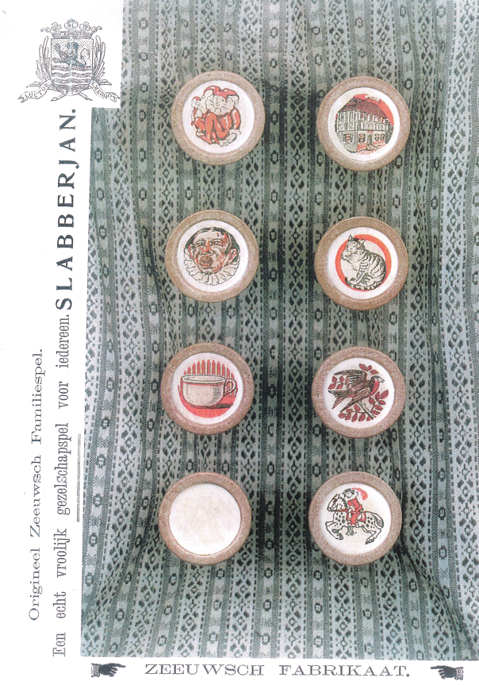

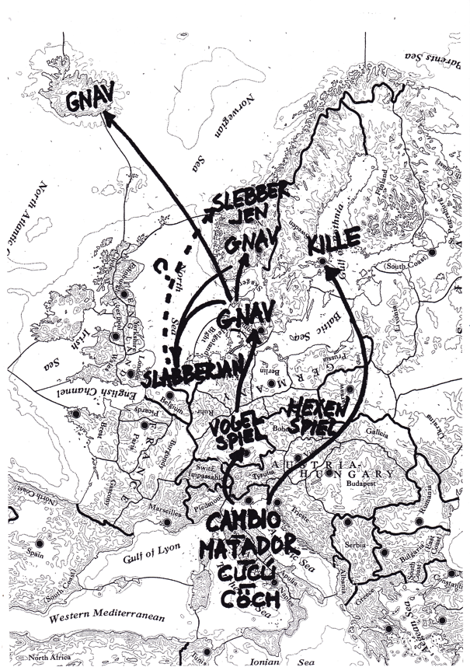

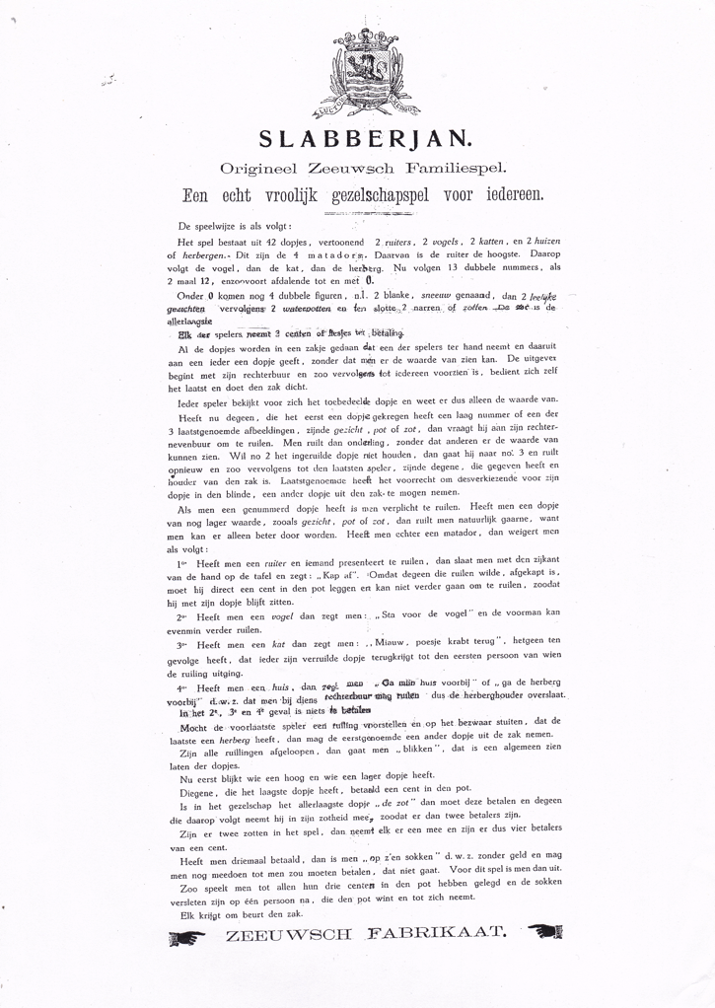
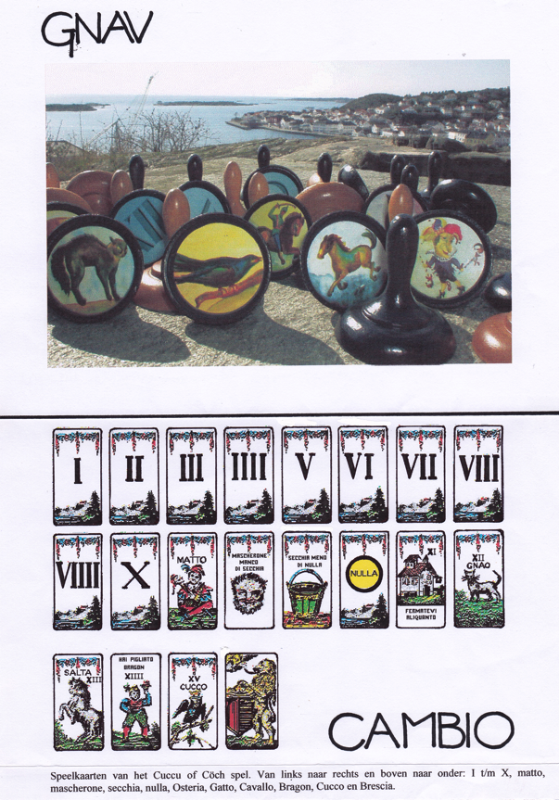

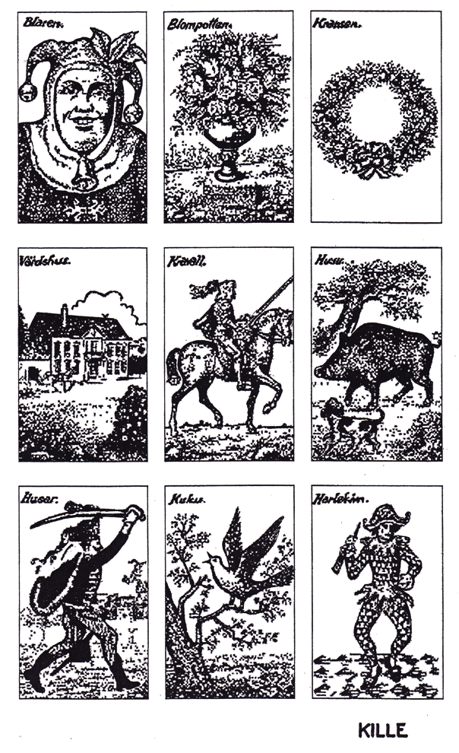
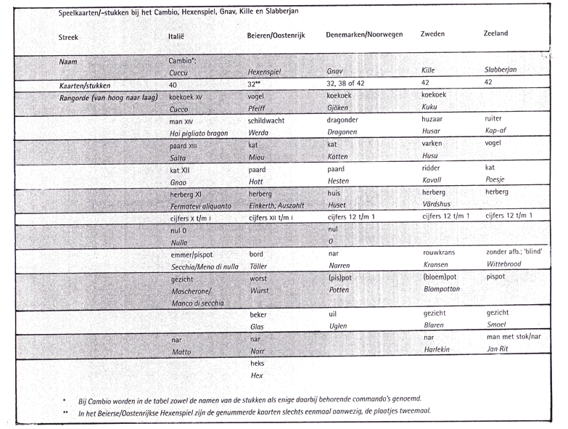

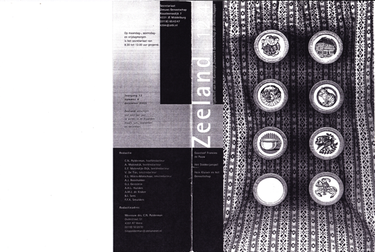

And the end-page of the article concerning the ‘references’.
