TRANSET
Visiting author/designer Harm van Veen
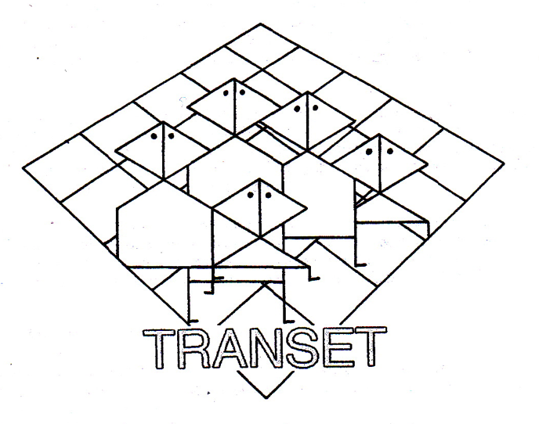

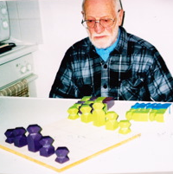

Introduction

Early in 2011, during one of my regular visits to “Haagse kringloopwinkels” {Recycle-Shops in the Hague} looking for Games, I did find a small box, wrapped in plastic-foil and filled with wooden blocks, which blocks looked like game-pieces.
I was curious enough to pick it up and examine the box and to my surprise at the backside a paper was visible with game-rules, giving the Rules for a to me unknown game : TRANSET.
For nearly nothing (less than 1 Euro) I became its new owner and when at home I was really curious about what I had just bought!
There was some surprise and a little bit of disappointment. Quick inventarizing showed me that all the Game-pieces were there but not the Board to play on. I looked at 10, obvious home-made, wooden Game-pieces which showed the hand of an expierienced carpenter and painter. To me they certainly were made by a craftsman with a special ‘design’ in mind.
Also a small booklet with game-rules and some leaflets with additional information were part of my finding. But the most important thing for me was what was typed on the back-side of the game-rules-booklet:

TRANSET-SYSTEEM

H.M. van Veen
Jul. Röntgenstr. 2
2551 KT Den Haag
tel/fax 070 3685539

beneath a wonderful stylized representation of the game.
“That will be smooth sailing” (I thought) to find more about this Game and it’s Inventor.
One call will do, but that turned out to be too easy: ‘no connection; phone out of order’!
Living in The Hague myself, visiting the Röntgenstraat 2 was not so difficult.
Again ‘alas’, another name on the adress-plate and none of the neighbours could give me information on mr. H.M. van Veen or his recent address.
Next and last option was surfing on the Internet which gave a “hit” on BoardGame Geek.

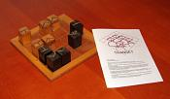

A photo of of the Game with the Pieces in a different color than mine and including the Board, but no more information about where to find the Author. What a pity for my attempts to do Research on Dutch Game-Authors.

So my search for information did end there and then and to comfort myself I made a nice Board to be able to play the Game with the found Pieces.

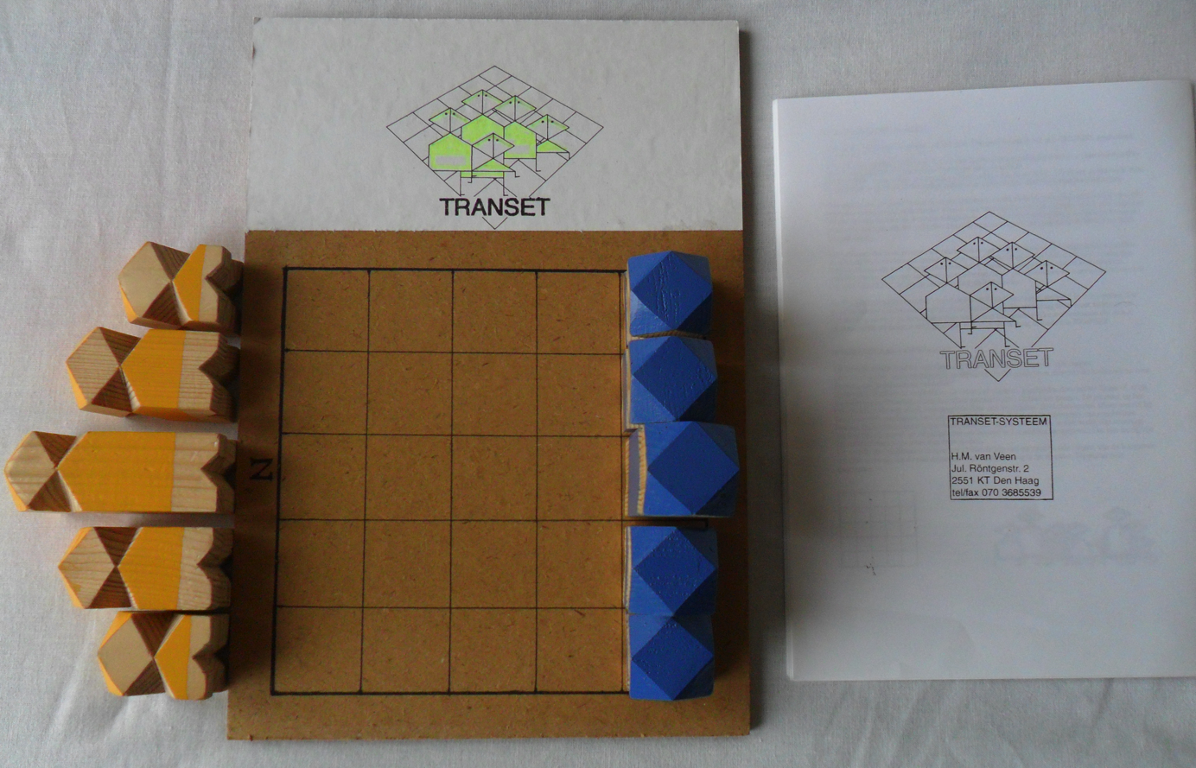

Follow up

Spring 2012 there was a gathering with some game-buffs and out of curiosity I did show them the TRANSET-game.
One of them was not satisfied with my way of searching and took the Phone-guide of The Hague; found a H.M. van Veen; picked up my phone ,dialed the number and handed the phone over to my.
No one of us was more surprised than me, outside the voice at the other end of the line, to find out that I really was talking to mr. Harm van Veen, the Inventor of TRANSET!
He had no hesitation to be interviewed about his Game, and: “No problem I was welcome the next day”.
On arriving at the Denijsstraat 201 Harm was fully prepared. In his small flat he had exhibited a large selection of all variants of his Game and he also had prepared a huge map with information from his files.

Harm van Veen

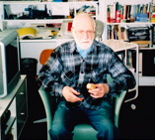

Harm is a fragile tiny Man who looks pretty vital for his age of then 87 years (in 2012).
Especially for my visit he had sorted out all information on his GAME and the living-room of his small Apartment was laden with a lot of different samples of TRANSET.

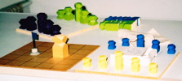

But before starting to interview him about the Game I wanted to know more about the Author himself.
Harm was born and raised in The Hague and did come from a ‘working-class’-family, where his artistic intensions were at first not really appreciated.
Although he got drawing-lessons and followed a training for becoming a childrens’- handcraft-teacher he got no Diplomas because of his inadequate former Schooling.
But that could not stop him from reaching his Goal, thus he did enter the Academy and was rewarded with the simplest certificate that allowed him to give Lessons in drawing. After some years of further study he got the “License for Handcraft” and became a Teacher in that discipline at the Bezemstraat MULO and there-after at the Dalton Lyceum located at the Aronskelkweg in Den Haag from 1957 until 1969.
After these 12 years he changed to a Job in Adult-Education in the Doctor Kuijperstraat.
Harm is now retired –already a long time ago- and as a result of the mental condition of his Wife he had to leave the Julius Röntgenstraat for a room in the “Wijndaelersch Centrum”, the same building as the “Retirement-Home with nursing care” where his Wife got nurturing.
After her death Harm changed to the Flat in the Denijsstraat .
Before his time at the Dalton, Harm was really interested in ceramics in such a way that he wrote a Book about Pottery which has been published.
His GAME came as a Result out of his programming the Lessons for School. To get the Pupils more involved Harm developed a game that could be manufactured by these Pupils themselves.
After checking the Rules with the Math-Teacher the game did become an integral part of his Lessons and a well appreciated item for the Pupils to show their skill at home.
Harm is absolutely convinced that you still may find his Game, with Pieces made out of a Broom-Stick, in many households in The Hague.

Leaving the Dalton meant also a change in interest concerning his Hobby:
No more Games, but ‘Vliegeren’ (fly Kites) and making ‘Vliegers’ (Kites) became his focus.
As an Associate to the “Stichting Nederlandse Vliegerpromotie” (Dutch Foundation for Kite-Promotion) Harm became deeply involved into his new Hobby.
He presented me his Booklet “Luchtig Lijntrekken” with cartoons published in the Magazine of the Association: VLIEGER.

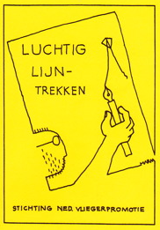

Harm was also a member of the Team that flew the largest Kite in the World in Scheveningen, but he missed the world-record for the smallest Kite.
Some Japanese guy got a tinier one into the air!

The Game TRANSET and its development

As said before, TRANSET originated as a “side-product” of Harms’ ‘Lessons in Handcraft’.
But the game has gone through many stages in design and name.
The first prototype was named “Vlaggenspel” after the Pawns that were different Flags.
But this was not what Harm had in mind so he changed to Broom-stick-parts and the name “KWINTA”.

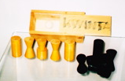

Under this name he also provided an Article on the Game in the Magazine “Na Vijven” (After 5 O’clock) with new disigns for the Pawns:

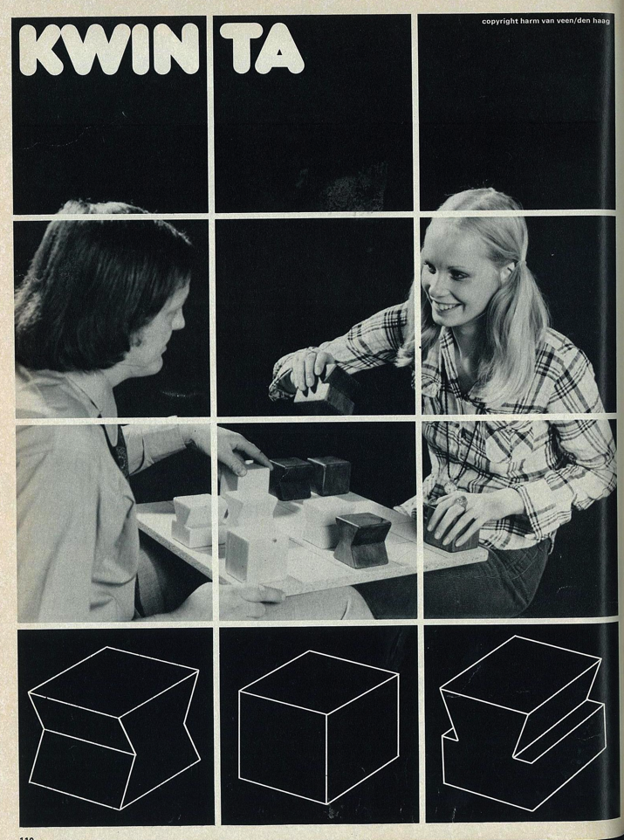

This Article triggered mr. A.J. Hardonk to make his’ own version, you can find on www.ogrogon.nl

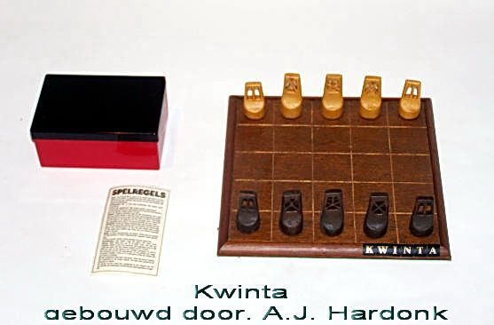

After leaving the Dalton the Game was laid to rest. All of Harms’ interest was now in “Vliegeren”.
But after his Retirement there was again time for the Game and Harm started to use “playing his game” as a kind of “therapy” during his volunteer work with Inhabitants of the “Wijndaelersch Centrum”.
But he was not satisfied with the “appearance”of the Broom-sticks, so his artistic background made him look for a more appropriate design for Game and Pieces.
With the new design came also a new name: PENTA

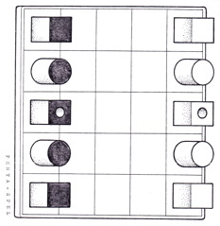
Harm was still not content, because he wanted Pieces which did look a bit like humans, because in the meantime he had dreamed up a complete story, about the land TRANSETIË, related to his Game and he wanted a fair representation of the Inhabitants.
Thus from wooden Blocks sawn with a special Saw he did create some stylized ‘man-like-figures’.
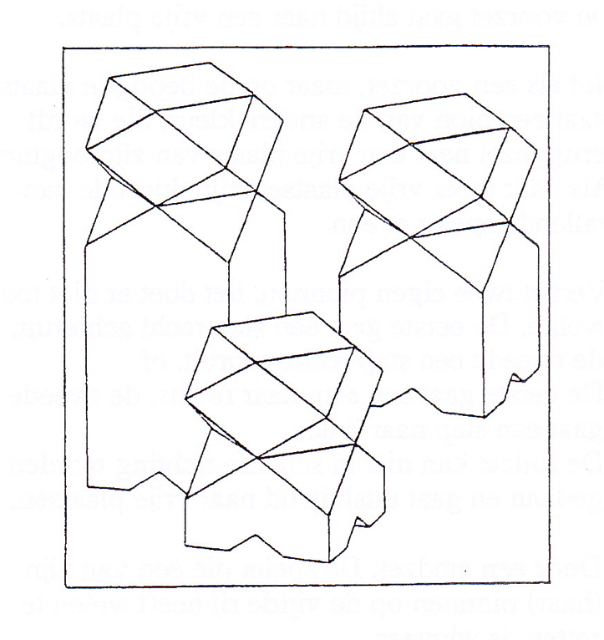

My found Pieces are like these:

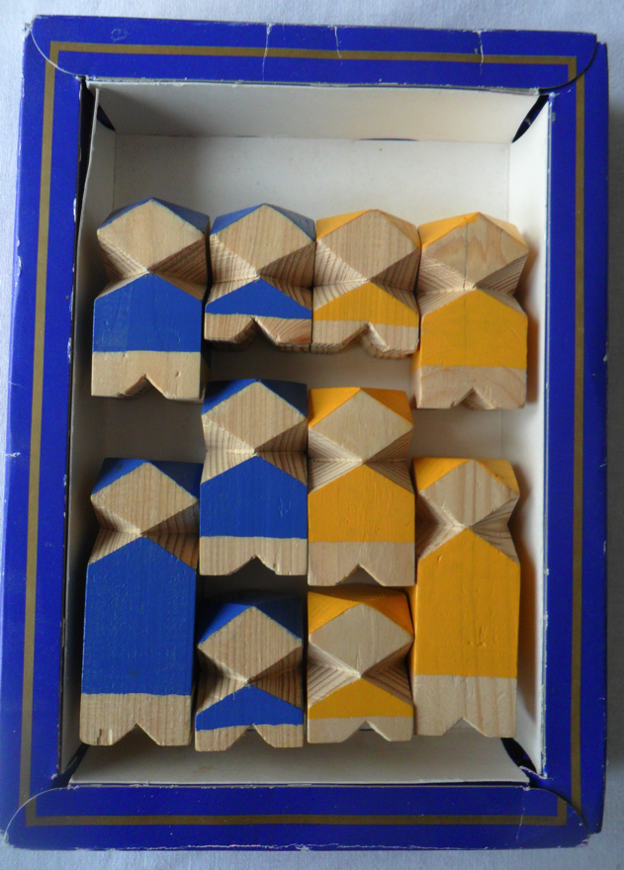

and the name of the Game has now become definitely TRANSET .
TRANSET

At first, as can be seen, Harm left parts of the Figures unpainted and at the bottom he ‘suggested’ kind of Legs. But this was a lot of work and after making a few Sets he opted for complete painting and a flat bottom.
So my found version is a rarity, and one of the first products of Harms’ new start with his Game.
In the early Nineties of the last Century Harm also started some sort of “production-line” and offered his Game for sale.
All Pieces were handmade and of all sizes, because he used every second-hand wooden Beam he could lay his Hands on, as well as the Boards which he manufactured out of all kinds of Material, like timber; hardboard; plastic; linoleum; even perspex or glass!
The Customer thus bought the Pieces and looked himself for a matching Board and he also got copied Game-Rules and a hand-made linen Bag to store the Pieces.
Harm thinks that he sold about 200 games; at most at the “Spellenspektakel” in Eindhoven where he did demonstrate his game for a couple of Years.

This is the Game I bought from Harm during my Visit:

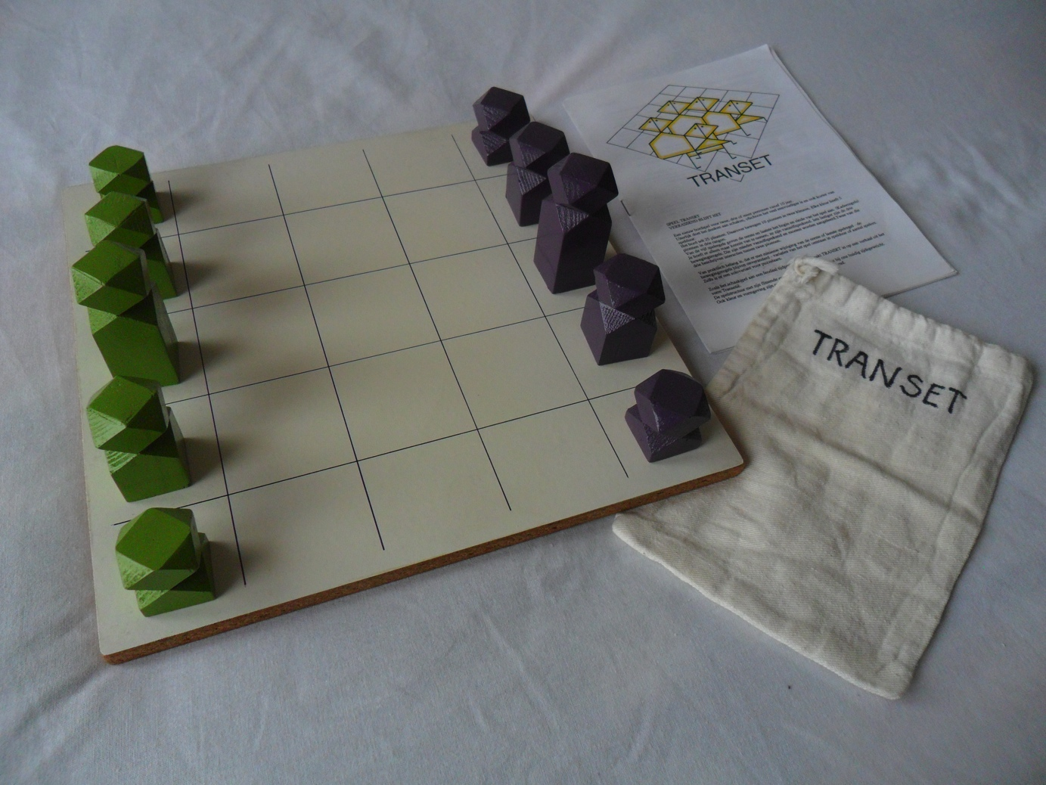

The WORLD of TRANSET

speel TRANSET, verrassend blijft het play TRANSET, surprising it is
wilt u weten hoe dat gaat? you want to know how it goes?
-nooit te vroeg maar steeds te laat- -never too early but always too late-
met van één kleur vijf pionnen with from one color five pawns
mag u zetten op uw beurt you may move in your turn
aan het eind hebt u gewonnen at the end you win
of –wat even vaak gebeurt- or – what happens in the same number-
hebt u een partij verloren you loose a game
moet u horen wat u wint: listen to what you win:
NIEUWE VRIENDEN door TRANSET NEW FRIENDS due to TRANSET
want verrassend blijft het because it is always surprising

With this Poem Harm begins his Story about the special World he did devise around his Game.
Then he tells about the Transetiërs, living in the North and the South with a Desert in between (represented by the Board) and the two Tribes identified by the light and dark color of the Pawns.
And each Tribe has different classes: 1) the upper class -the highest Pawn- the PIAS ; 2) the middle class the PIOKER ; 3) the lower class –the smallest Pawn- the PINET :

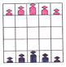

Of course at the other side of the Desert everything is better, so the People of the two Tribes try to reach the other side. The Game ‘tells” the Story of this Migration.
Harm typifies his Game as:
TRANSET is in fact a kind of mental “pingpong”(table-tennis).

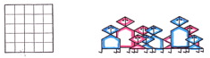

Game –Rules

TRANSET is played with only Five Rules as Harm explains:

Number 1 and 5 are, in his opinion, kind of ‘Agreements’ and 2, 3 and 4 are ‘Rules how to Move’.

1) START
The light-colored Pawns are placed on the North-side, the dark-colored on the
South-side, with the PIAS in the middle, the PINETS at the edges and the PIOKERS
in-between (see picture on page 10).
The dark-Player (South) starts and then Moves go alternately
2) MOVE
a) PINET One square straight ahead
b) PIOKER One square diagonal, left or right, ahead
c) PIAS One square straight, or diagonal left or right ahead
(combination of a and b)
A Pawn can only be moved to an empty square
3) CAPTURE
When the square to move to is occupied by an Opponents’ Pawn, this Pawn is
captured.
The Player ends his Turn by replacing the captured Pawn on the Board upon an
empty square of the Opponents’ starting Line
4) MOVE with “SWOPPING”
a) straight ahead and back
Move TWO own Pawns, no matter which. One moves one square straigt ahead, the
other one square straight backwarts, both only if the squares to move to are empty
b) sideways left and right
Move TWO own Pawns, no matter which. One moves one square sideways to the left,
the other one square sideways to the right, only if the squares to move to are empty
5) END
a) by making an “end-move”
When a Player reaches in his Turn the other side of the Board with one of his Pawns,
play ends immediately and this Player wins the Game
b) by resignation
When one Player resigns, play ends and the Opponent wins the Game
c) by draw
When both Players agree to a Draw there is no Winner.

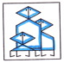

VARIANTS

All this was not enough for Harm and he also developed some Variants based on the Rules for the ‘normal’-Game.

+First he did invent PIASSEN as an introduction to ‘How to play’ with the Pawns.
Only the two PIAS-Pawns are facing eachother on a further empty Board!
This is really only for learning how to Move. When analyzed it turns out that the ‘light-colored’ always wins.

+TRANSPLUS
In this Variant the Game does not end when a Player reaches, with one of his Pawns, the other side of the Board.
Rule 5, part a) changes fort his Variant into:

5) End
a) by making a 5th “end-move”
When a Player reaches in his Turn the other side with one of his Pawns(“end-move”)
this Pawn is removed from the Board.
The Player who gets his 5th Pawn off the Board in his Turn wins the Game

+TRANSET for more than 2 Players

Variant for 3 =TRANSTRIO=
Players A, B, C; alternate Turns: A B C A B C A etc. etc. So in two consecutive own Moves a Player changes color and direction of play.
First Player who makes an “end-move” in his Turn with his coler of that Turn, wins.

In the same way as TRANSPLUS TRANSTRIOPLUS can be played.

Variant for 4 =TRANSKWART=
Players A,B,C,D; alternate Turns: ABCDABCDAB etc.etc.
Players do not change colors during their Turns. A & C and B & D are partners now
and win or loose together.

And again, why not play TRANSKWARTPLUS ?

Variant for >4 =MULTITRANSET=
All Players are sitting around the Table and use the same following of Turns clockwise!
A complete Group of Players, when an even Number participates, can win!

And, if this was not enough, still Harm suggested MULTITRANSETPLUS !

+And for Harm it was not enough! What if you bring some kind of luck into the Game?
Take a Six-sided-Die with on the sides the 3 different ‘classes’ of Pawns and the 3 different ways to move Pawns: MOVE / CAPTURE / SWOPPING , and you get:

CHANCET

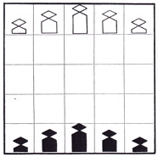

In his Turn a Player first rolls the Die.
This indicates:
= Which Pawn to play. The Move is related to the Pawn: Moving; Capturing or Swopping
or
= Which Move to play. The Pawn(s) to play is the Players’ choice
If it is a non-feasible Throw, Player rolls again untill he can make a legal Move.
All Rules for TRANSET apply also for CHANCET.

Harm ends it all with one of his beautiful sentences:
“He, who can play CHANCET, can - by not using the Die - play TRANSET”

There is much more to tell about Harm and his Game and the Fairy-Tale about the TRANSETIERS. And then I still miss all about the Book Harm started to write concerning his Game; and the different ways to register your games and ……………………………
This all is written down in the Dutch version of Harms’-Game-Story. Ask for it, it is fun!

Fred Horn
For Board Game Studies 2013 at the Azores Den Haag, 8 March 2013

Annex

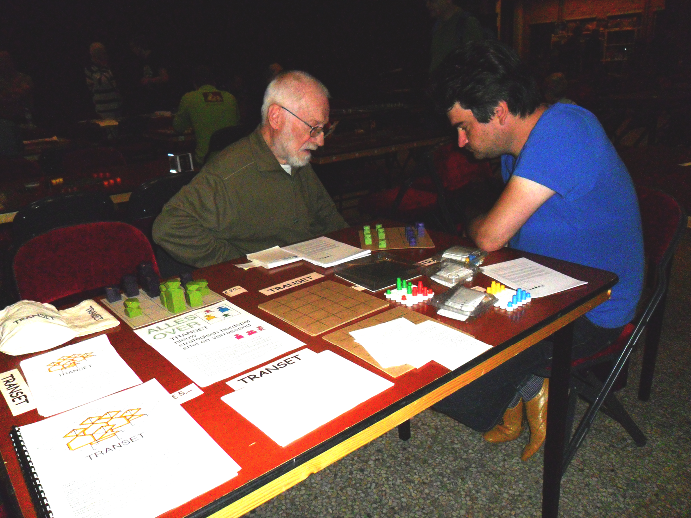
Harm van Veen playing his Game at the Ducosim-Gathering Amersfoort November 2012

