THE GAME
A small Story about an unknown Game by Fred Horn
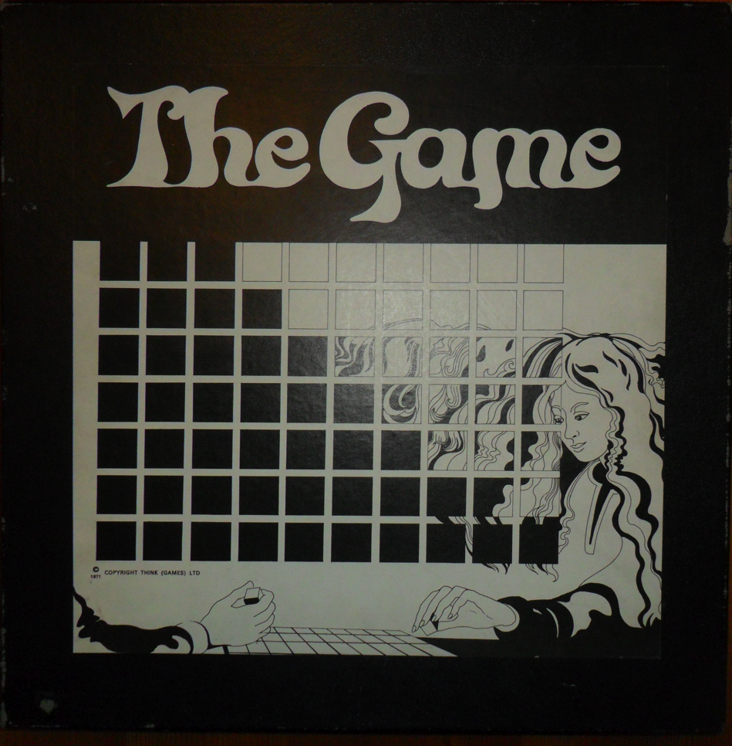

Although always interested in these kind of Games, in the early seventies of the last Century I started to look more explicit for abstract/stragegic Games.
One day in 1974 I was passing by the Rosenthal Studio House, located on the Heiligeweg in the centre of Amsterdam, when my eye catched some objects that looked like Games.
These were part of a large Sell-out and everything was priced down.
Going inside I learned that these things were really Games AND that these are the last items from their former game-department which they had ended because of bad results.
Although for me, at that time, the prices for the objects were still far above my normal budget, I had just earned some good money with making music: some well-payed jobs!
So there was no hesitation and I bought all the exposed Games, including this one and another of the same Firm: POLYOPTOMY (a 3-dimensional Tic-Tac-Toe-Game).
For “The Game” they provided the wonderful design-box shown above, but for POLYOPTOMY the box has been lost and all parts were put in a plastic bag!

When at home both Games proved to be worth their purchase because it was fine playing. Especially “The Game” I did (and still do) like very much, because it has few and simple Rules but in contrast a not so simple strategy.
Besides that these Games are really design-objects, look at the marvelous Perspex Board and Pieces of “The Game”:

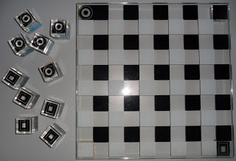

they also are of high-quality author-autenticity.
At that time I was only interested in collecting. More than a decade later “What is the story behind games” got my interest and I did start doing research, mostly about Dutch Games and Dutch Authors.
But I also found that beautiful “The Game” worth researching.
I only had the name ‘Leisure Dimensions Ltd. Made in England” on the Rules and
‘THINK (GAMES) LTD. 1971’ on the Box to my disposal and at that time there was no Internet nor what-so-ever else, which ment that I wrote Letters to all kind of Archives, but no Information popped up, so after a while I lay this Research to rest.
For my birthday in 2000 mr.Ruud Pit did present me the complete Issues of “Games & Puzzles” from the seventies and to my surprise I found one Add on the subject in its’ first Issue with an Address and Phone-number:

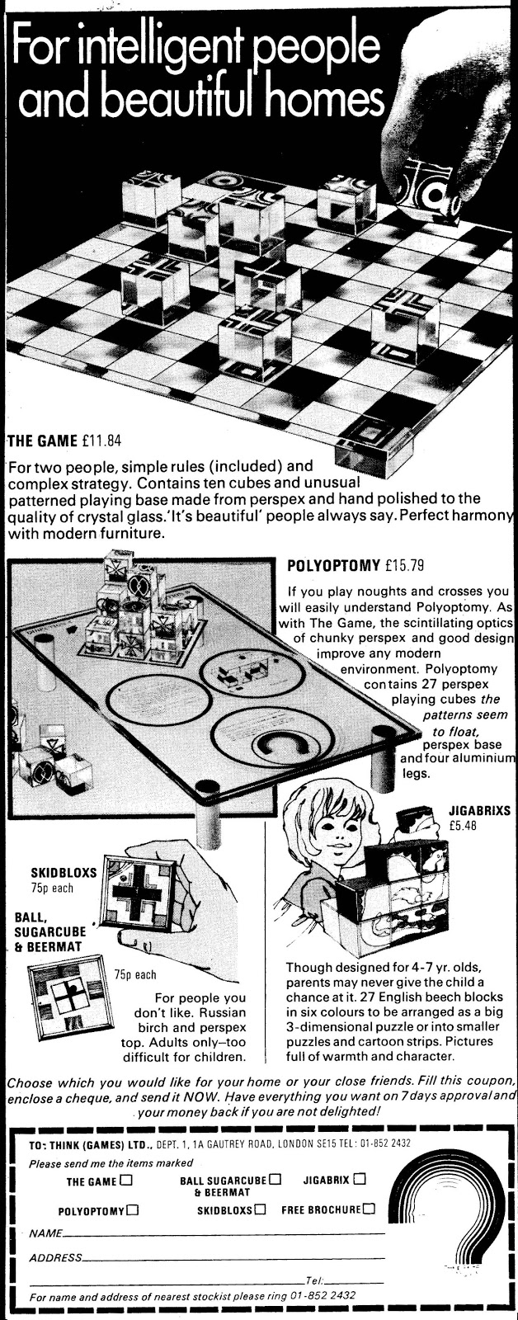
But unlucky for me these has no connection anymore to something in our present time.
For the second time no trace of this mysterious Firm comes to light.
The only surviving, as far as I know, Box is now in the Vlaams Spellen Archief in Brugge.
I did translate the Rules for the website of João Pedro Neto: <http://sagme.blogspot.pt/> from Dutch into English.
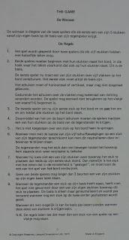

Are there Collectors with more information about this Game, its’ origin, its’ Author(s) ?
I really want to know!
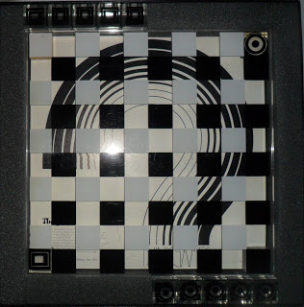

Supplement: Translated Rules.

