STRAAT
Some unusual unknown Game from Holland
====================================================================
STRAAT, a one-time-game-idea by Fred Schuurhof

More about Fred Schuurhof (in Dutch): www.home.kpn.nl/schu3988/mobiel.html
====================================================================
In September 1984, returning from my Holiday, one of my colleagues from the “Organisatie-Bureau van de Gemeente Amsterdam” where I was working, attended me on an Exhibition of Games that would take place within a short time at a small Gallery in the Jordaan- the workingman’s living part of old-Amsterdam-.
Thinking I would like it he already had put my name on the list to be invited.
Not long thereafter I did receive a postcard in which the Exhibition was announced:

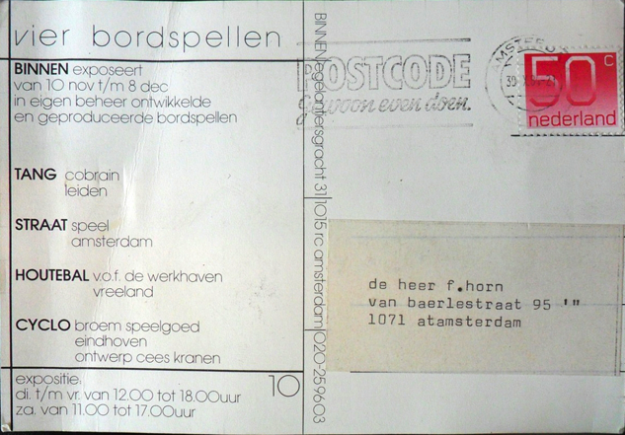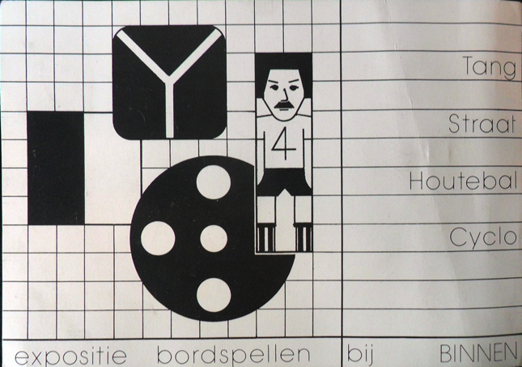

It was held in the Gallery BINNEN –Eglantiersgracht 31- and it turned out to be an Exhibition of only 4 Games.
I was curious about them, because I had never heard of or seen these Games, so these games could be a nice addition to my Collection.
HOUTEBAL and CYCLO were not that interesting for me, but the other two: TANG and STRAAT were exactly “my cup of tea” +abstract/strategic games+.
In the end I did buy all 4 games and they are now in the collection at Brugge and documented at the Dutch website: www.hong.vlinden.com .
The complete story about TANG and the small firm COBRAIN (Jonathan Schouten & Paul Velleman) is something that will be told in the future, but during my research for that story I also tried to locate the small shop SPEEL that had published the game STRAAT.
But in the late 90th of the last Century the shop did not exist anymore and searching on the Internet was something you not even knew about!
When Rob van Linden put my information about these 4 games on HONG, he looked further and and found the name of the author of the Game: Fred Schuurhof .
With a website about his work as a photographer it was 1) easy to locate him and
2) to make contact to get more information about him; his game; his shop.!

Let’s see what Fred has to tell after he received my message:
====================================================================
“ What an extremely surprising message I did receive from you.
Indeed an echo out of the past from a long time ago. Very curious to find out the game STRAAT still do have some place somewhere. For me it is hidden in a dusty corner of my memory, although in some closet in the house I still keep a tangible sample.

In the 80th I was very busy for some years to handle with a friend the firm Speel, a game-manufactory with at most its own hand-made products. This was some reaction on my not so concrete (in those days) job as a youth-worker.
It was an intense and creative period for a stimulating firm, but it failed in its business sense.
For years I was deeply involved with the board-game Carrom, a dexterity game from India (some kind of ‘poor-mans-billiard’) trying to give it more attention in the Netherlands, but at a certain moment I could not combine it anymore with my daily job.
Although bringing in heavy PR and a lot of time the Dutch were not interested in Carrom after all.
With the factory we made Carrom-boards, but I also organized tournaments, even international ones, with people from Germany, Switzerland, India and even Sri-Lanka;
I looked after all the work in the association: secretary;handling the journal etc.etc..
When it became too much I quit, but the game itself is still my passion and with a small group of friends we still play the game!
In 1988 we closed the shop and the manufactory and up to my retirement, in 2012, I started to work as a photogrpher for the Vrije Universiteit in Amsterdam.

Returning to STRAAT, this was an idea that came to my mind when the Gallery asked for something as part of their Exhibition on new games. To be fair, I did not play the game very much because it was hard for me to “image” both sides during play and lay down the pieces strategically. We did not produce the game in large amounts and as far as I remember it also sold poorly. At the end both the game and the firm Speel did die patiently.
Of course I do like the idea that somewhere the game is remembered, but for me it is something from the past and not a possibility for the future.
The game Straat was invented and submitted 30 years ago on the spur of the moment, but from that moment on I never looked after it. I think it still needs testing and developing, because it is a game asking for good memory and abstract-thinking to visualize and remember how the ‘lines’ go on both sides. For me it was (and is) too complicated.
When the game could be some inspiration for young inventors I will be more than satisfied.
I nearly forget to mention that this game is the only one we, the firm Speel, developed ourselves. At most we were busy manufacturing luxurieus, mostly wooden, designs of well-known board-games like backgammon; chess; halma; etc..
To end, I will mention the name of my friend and partner in business: Rob van der Wardt, still a good friend. “
====================================================================
So far for Fred Schuurhof as his story goes.
But what IS the game?
-----------------------------------------------------------------------------------------------------------------
Front side with removable transparent lid Mirrored back-side
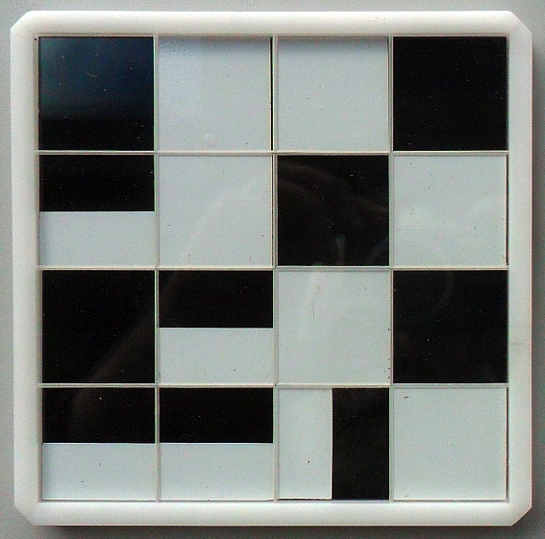
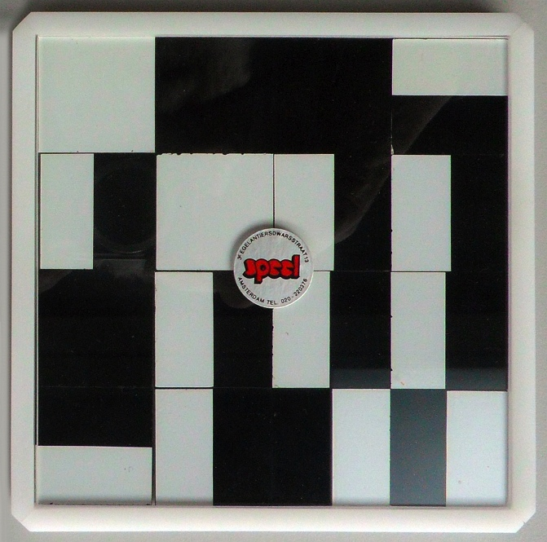

This is the example of the game STRAAT that I bought at the Gallery BINNEN. Some time later I also bought a version, with blue in stead of black faces, at “de Bijenkorf” a large department-store in Amsterdam. Both are now in the Vlaams Spellen Archief in Brugge. F.H.
-----------------------------------------------------------------------------------------------------------------

The Idea behind STRAAT, playing in your Turn on the visible side as well as on the other –not visible- side of the Board, was for the time innovative.
I still do not know many games that explore this principle.
After all these complains of Fred Schuurhof about his game the funny thing of it is:
I played the game very often especially with mathematical interested friends. But it still is an unknown game in the world of abstract/strategic-games.
The game is nowhere mentioned in works on “Connection-Games”, but this omission can now be rectified and corrected on behalf of this article!
One of the few other ‘games’ with a similar principle is Alex Randolphs’s FAX, but that is more a puzzle than a game.
The problem here is to solve the puzzle at both sides, one side a H, other side a U:


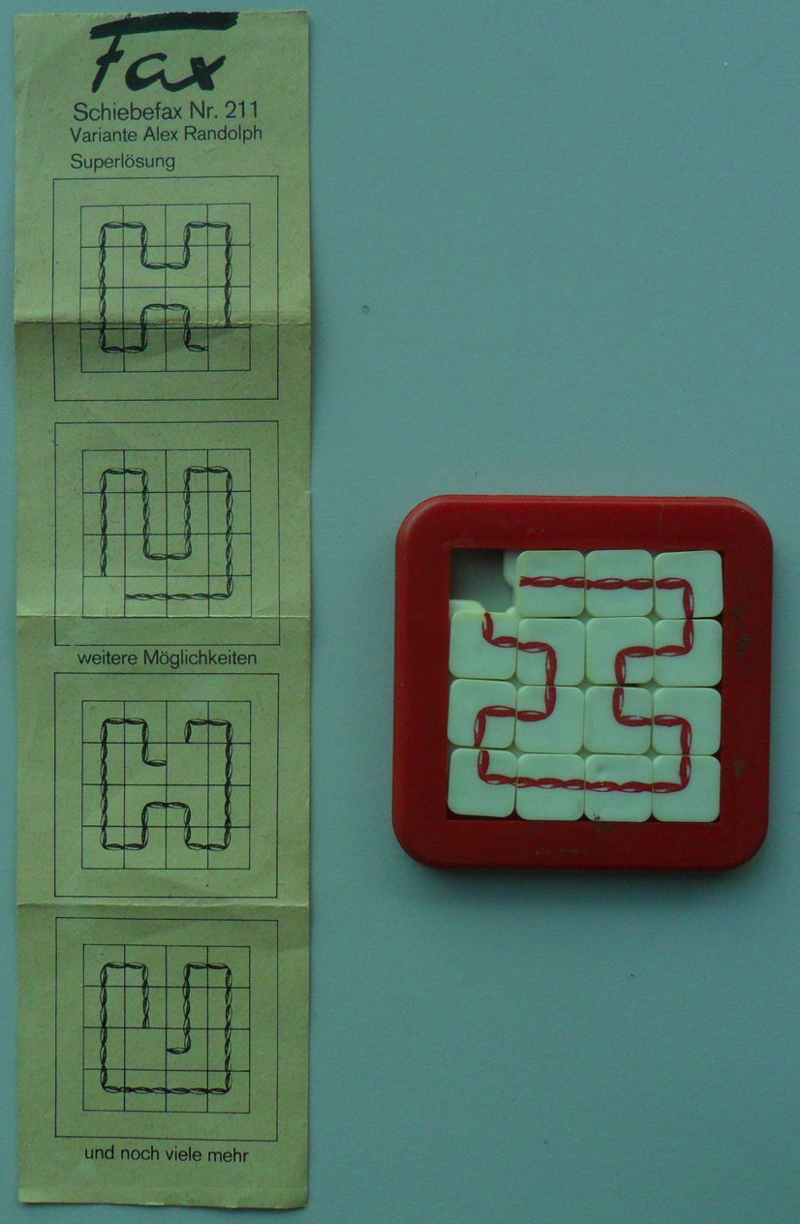

Gerhards Spiel& Design from Germany has published the game MOGULI from my friend Reinhold Wittig.
In this game you really play on both sides!:

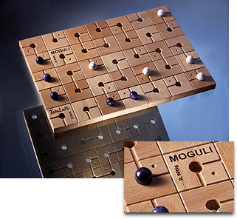

And then there are all kind of games with magnetic devices and a hidden labyrinth underneath like GOBLIN’S GOLD from Jumbo.
But with STRAAT I can only say: “Small – 10x10 cm board- Material Great Game”.
I do finish with a picture of the original Rules (in Dutch) of STRAAT:

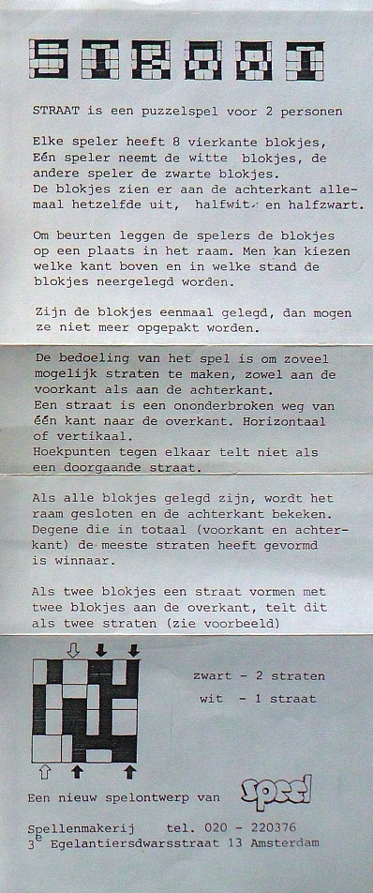

Maybe someday we experience a Rivival of this most interesting Game. Fred Horn.
18 August 2013

Supplement:
Translated Rules in English
SUPPLEMENT:

STRAAT © Fred Schuurhof 1984
====================================================================
STRAAT is a Puzzle-game for 2 Persons.
Equipment:
16 Square Pieces, each on 1 side half-Black/half-White and on the other side 8 total-Black and 8 total-White.
Play-frame of 4 x 4 Squares from transparent material (glass/perspex/etc.) .
Transparent lid to cover the Pieces after filling the frame.
Rules:
One Player takes the 8 all-White- the other the 8 all-Black-Pieces.
White starts. In his Turn a Player lay down one of his Pieces to his wish anywhere on the Board, according to the grid. The orientation is up to the Player.
When all Pieces have been placed, each Player counts his Straten (Streets) :
–a connection of opposite edges with his color-
place the lid and turns the Board over and also counts his Straten on the back.
Player with highest sum WINS.

Back- and Front-side of the Board (mirrored).

