4/5 DE NATIONALE LEGPUZZLES
Some thoughts on and a Solution for this intriguing Dutch Puzzle
By FRED HORN 14/01/2013

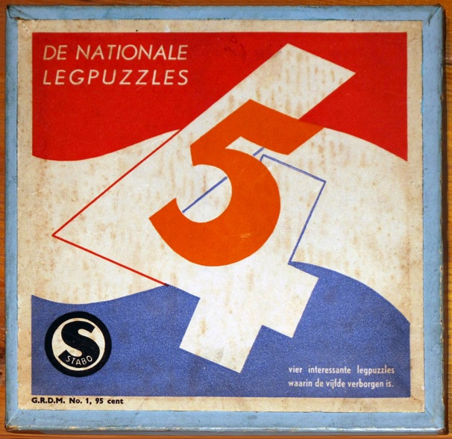

Early January 2013 mr.Rob van Linden put this picture on his website devoted to Dutch Games <hong.vlinden.com/index.asp?u=&z=nationale%20legpuzzle&zio=j&vi=li&uz=n>
The Puzzle was delivered by mr.Han de Bruin from his own collection.

Interesting is the Idea: Give the Puzzler 4 puzzles with a next one hidden inside.

About the firm STABO nothing is known.
On HONG you can find one other item from this firm: Spijkertje-vast.
G.R.D.M. is part of the G.R.-code-list, which was used for printed items between 1944 and 1950 in the Netherlands, regulating the price, which is here: 95 cent .
Probably the Puzzle is from 1945, because of the Dutch ‘spelling’ and the used 4 and 5.

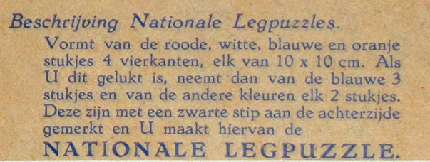

This is the assignment for the Puzzler:
Make a Red; a White; a Blue and an Orange “10 x10 Square” from the pieces.

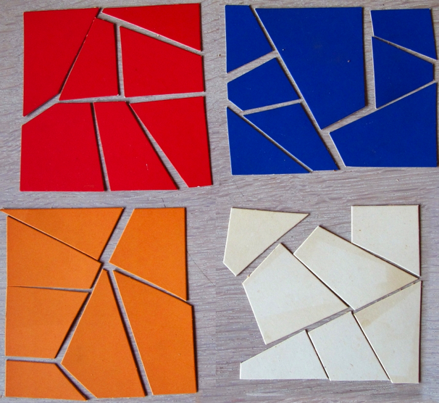

The Red and Orange Squares are already layed down in the proper way, but the Blue one needs re-arranging and the White Square is a complete mess, with obvious 1 piece missing.

The 5th Square has to be made from the pieces with black dots on the backside, using 3 Blue pieces and from the other colors each 2 pieces:

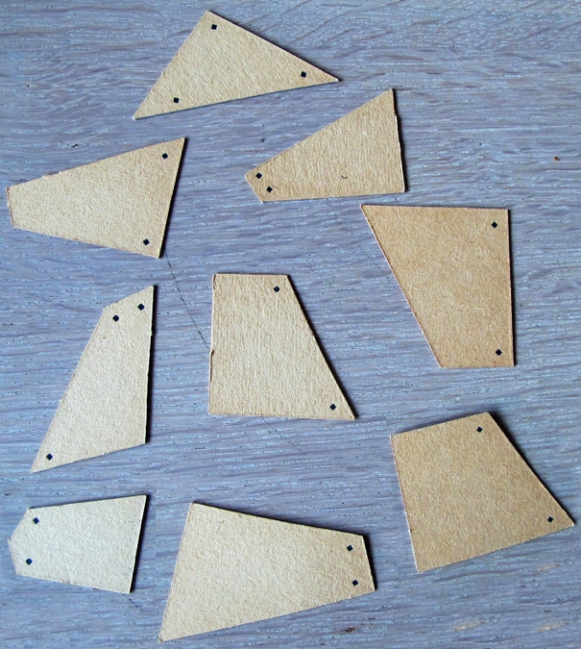

Because of the very bad way in which the Puzzles are punched out of the cardboard it is at first not so easy to lay down the 4 Puzzles. The dimensions are altered because of the not all too good, let’s say pitiful results of the punching.
Luckely for me, all the pieces with black dots on the backside were there.
Solution for the Puzzles and a Suggestion for the right Dimensions

The solutions for the Red And Orange Puzzle was, as I said before, easy:
The photo already did show it.
For the Blue one it took me several hours.
I only had the photograph from which I made a print-copy. I did cut out the pieces to discover that all dimensions had been distorted and at first nothing really could be fit together.
The White one was even worse!
Because of the missing piece and because of the not too good shape of the pieces, I failed to find the solution.

Thus I tried the other way around and started with the 5th Square.
At a certain moment I realized that one of the Red pieces was far too small, but this arrangement of the pieces must be the SOLUTION! :

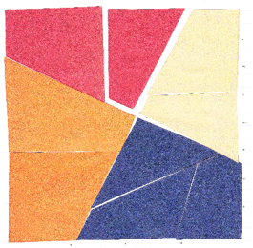

With the White pieces in the right position within Puzzle 5 it again took me several hours to get a proper solution for the White 10 x10 Square.

But still I had no idea of the REAL dimensions.
After some trial and error and measuring all the sides and angles of the pieces some idea, of how these pieces were created, did come to my mind.
The next explication is what I think of the method which was used to create the Puzzles.

The 10 x10 Square is divided in a ‘grid’ of 16 x16 small squares.
Taking the 5th Puzzle there are 2 crossing lines under an angle of 90 degrees, separating the 4 colors.

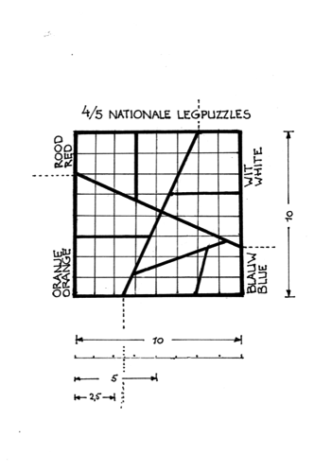

Using the same ‘grid’ for the other 4 Puzzles, I first put the pieces (with the black dots at the backside) into their proper position.

This resulted in the following Solutions for the 4 colors:
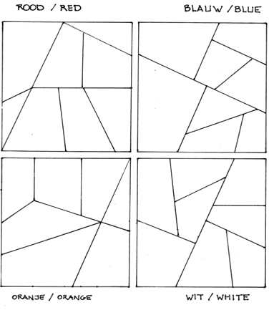

I did send the Solution to mr.Han de Bruin and he answered as follows:

“ Looking at the original pieces the ‘punching’ is much better than what you realized by copying and cutting out.
I did lay out the 5th Puzzle and this is the result:
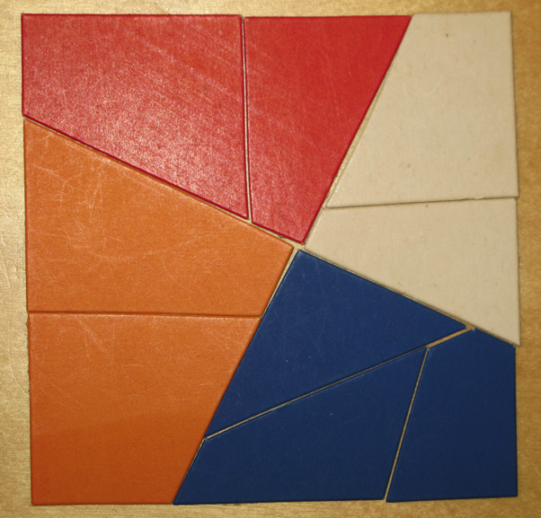

Anyhow you did a nice piece of work! “

With a better picture at my diposal I can now see that I made one mistake concerning the ‘slicing’ of the 2 Red parts.
To get the original Puzzle the vertical line should be 1/16th to the right!

But let the way I did it be My Variant!

