“Author meets mr. Murphy”
A funny story about game inventing and selling Fred Horn 21 august 2013
====================================================================
Introduction
Sometime in 1987 a friend of mine, owner of an Advertising-Agency, told me that an ‘account’ of his wanted a Game and asked me: “Are you interested?”, knowing my involvement with games.
Of course I was and so we soon had an appointment at the ‘account’s office which turned out to be a part of the firm ICI Holland B.V..
For their 60th anniversary they wanted something special next and in reletion to their playful portfolio-presentation ‘TASTBARE COMMUNICATIE’ (tangible communication).
Their own PR-department was also present at the meeting and asked for what possibilities my friend’s Agency could offer. He introduced me and I started to explain what wide range of possibilities there are when you want a Game, but time after time I was interrupted by these 2 PR- man and women- freaks who knew everything better and also tried to teach me complete rubbish about how inventing games.
Was it not for my friend, I had picked up my belongings, wave ‘goodbye’ to them for never returning again.
But now, almost be bursting with rage, I let it go and continued to explain what I had in mind for their game. In the end I made some ‘sketches’ which we left there.
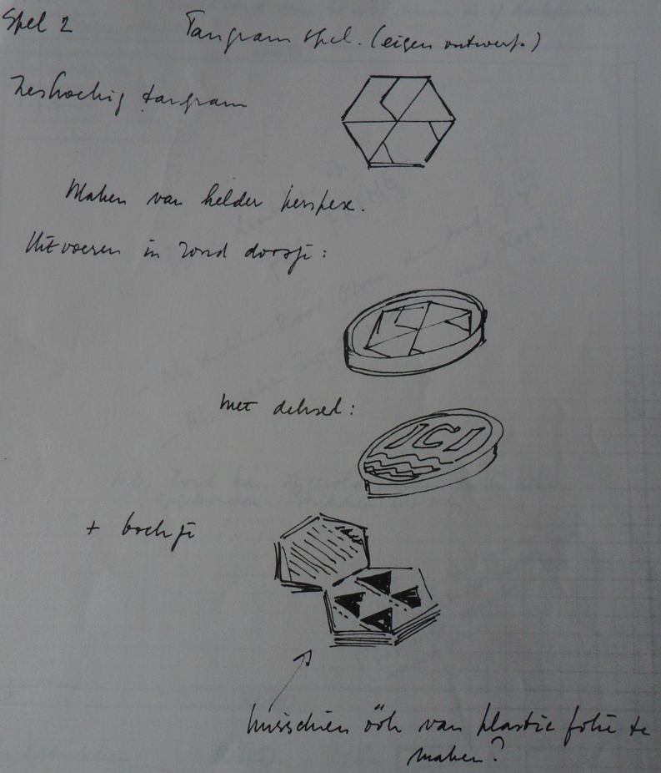
My friend asked me to start thinking about some of my suggestions and one of these was a hexagonal Tangram:

To my great surprise, I was really thinking that I had messed up my friends ‘account’, after a week he phoned me that I had done great and that they wanted an execution of 5 of the games I had presented.
====================================================================

Realization
His Agency now took over and they made a nice presentation of all 5 options:
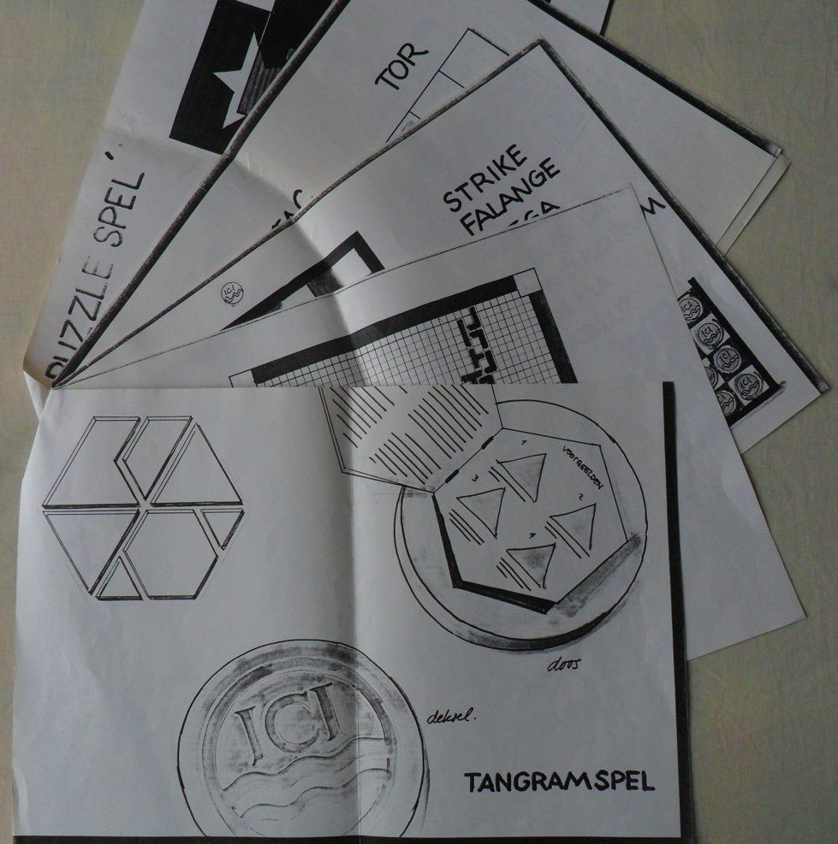

In the meantime I had visited the ICI plant to know more about their products. I was send home with complete documentation and a bag full of samples of these products. This turned out to be important because, via my friends Agency, they had let me know that the game also must use as many of their products as possible!
That was a complete new and a not so easy to realize constrain, thus we again had to meet these 2 PR-freaks.
One thing was easy, because they had decided “to go for the Tangram”!
After an hour with these 2 I was again ………… and ready to go! They had given us only stupid suggestions what to do with that new constrain of using all the ICI-products and now my friend also got angry, let them shut their mouth and asked me what solution I had in mind.
Because the bulk of their products did consist of ‘plastics’ in plates or leaves and all kind of products out of transparent PVC, I suggested a box out of a transparent (round) pipe; the tangram itself out of transparent ‘bricks’ and as a ‘fill-in’ round the tangram in the box a stack of all kind of their products out of leaves.
We all agreed and I promised my friend to design a complete instruction how this could be made, so he could offer this to ICI with the financial consequenses.
====================================================================
Presentation
Within a month both me and my friend were summoned immedediately to have a meeting with the highest boss of ICI Holland B.V.. The ‘top’ was mad like dogs about what had happened with that game and they blamed it all on us.
With the invested money only 100 games had been produced for an internal price far higher than 100 guilder. And all that for some funny extra to their 60th anniversary!
Not impressed by all this and wearing my best suit the first thing I did ask of course was: “Can I see the manufactured Game?”.
That took some time, but a sample was unearthed and put on the table. The package was opened and out came a complete surprise! A nice hexagonal plastic box, but in execution far away from what I had designed and had worked out for the manufacturers.
That was the moment that I had to think of mr. Murphy! In his “LAW” he states: “When something starts to go wrong everything goes wrong” and here I was, meeting mister Murphy.
Not impressed by the ‘Boss’ and completely ‘flabbergasted’ about what was presented on the table I said: “But this is not what I did invent or had designed for manufacturing!”
The ‘Boss‘ was also not impressed and asked for the “Chief of the Workshop”, who stated, after his entering the room, that: “This is exactly what I am asked to produce”.
My friend opened his case to show the Chief what I had drawn and what instructions I had given for the production.
Completely confused the Chief produced my first ‘sketch’ and looking at these 2 PR-freaks said to the ‘Boss’ : “That’s all they gave me” leaving the room.
I have to say that the Chief and his man had done a great job and looking at the product it is easy to understand were the money has gone!
All the ‘Boss’s anger turned to these 2 poor PR-freaks but there was more trouble in the air.
On the highest level they had decided that the 100 produced Games became part of a sales-promotion-campaign and should not be used for the portfolio-presentation.
Every sales-manager should get one to use it for giving away the game-pieces as examples of their products.
I was bright enough to pick up the tangram-box on the table, replace it in its package and say “thank you” to the ‘Boss’ for the one for my files.
Afterwards I did hear from my friend that ‘he was not amused’ with what had happened, but the same could have been my commentary.
====================================================================
The TANGRAM
The one I own is perhaps the only complete surviving example, and here it is in all his greatness:
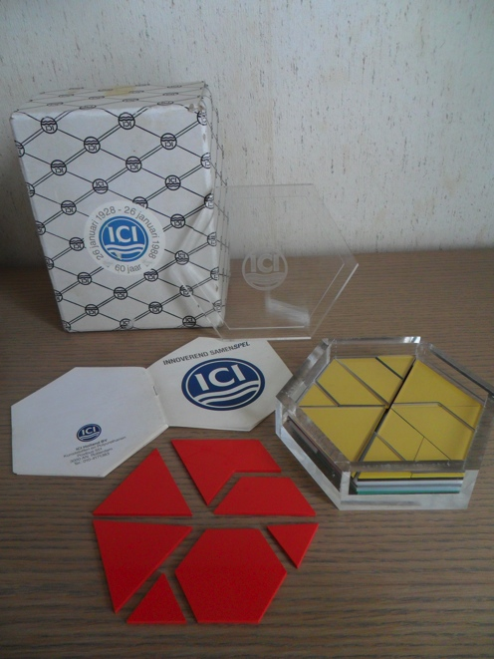
More

Years later the firm Nova Carta did use the same design for one of their products they sell on the business-to-business market as a Christmas-give-away:

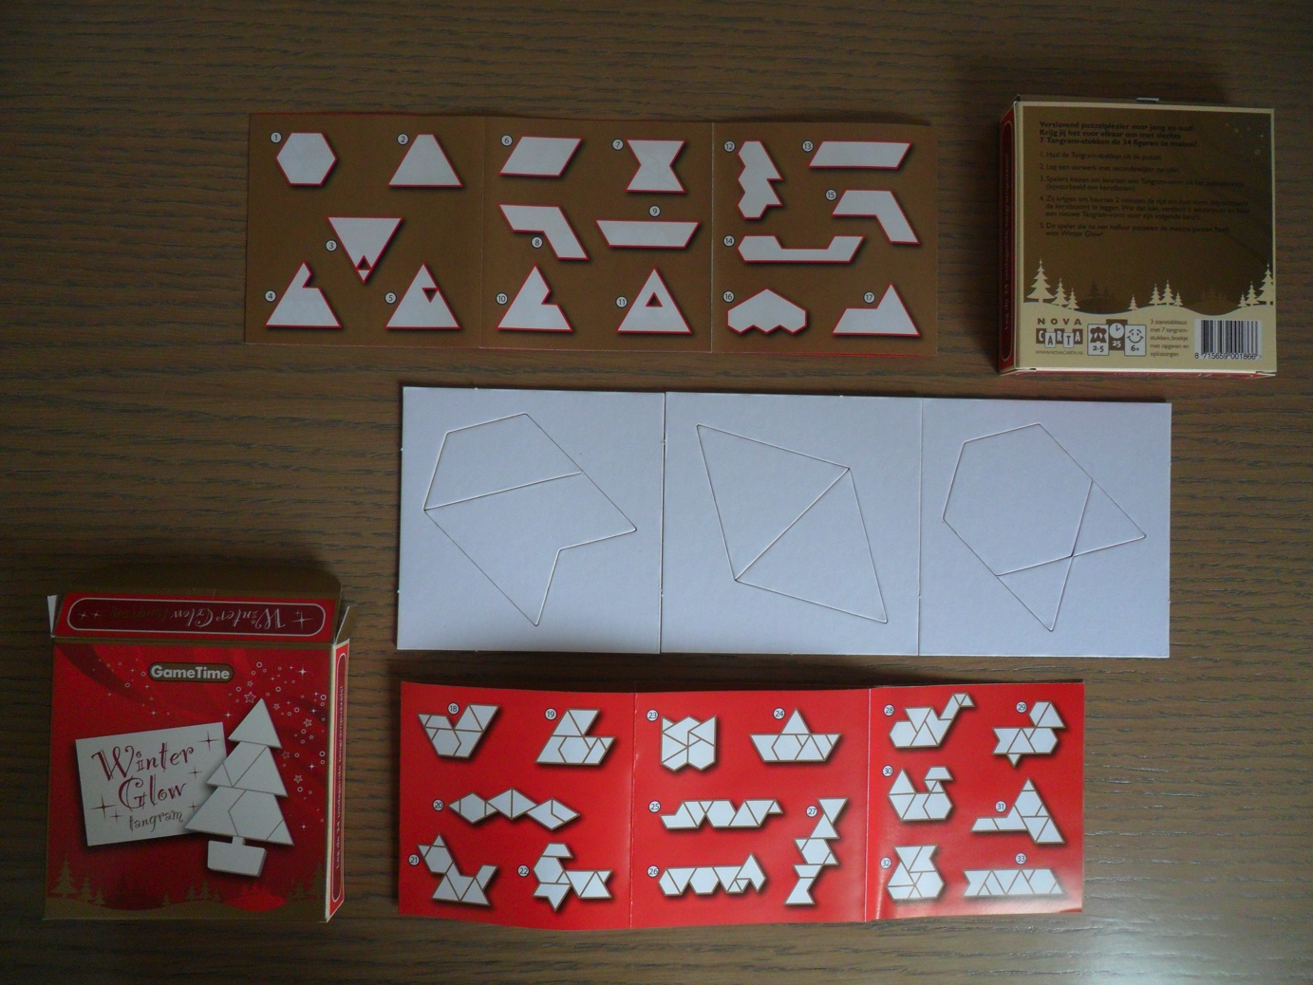

I still have some of these Winterglow, so if you are interested put 5 Euro or 5 Dollar in an envelope, do not forget to mention your address and send it to;
Fred Horn , Doornstraat 16 , 2584 AM Den Haag , NL-Holland
and you will get one.

